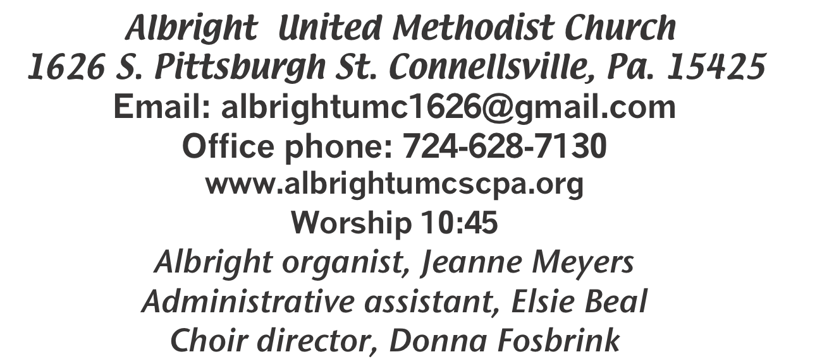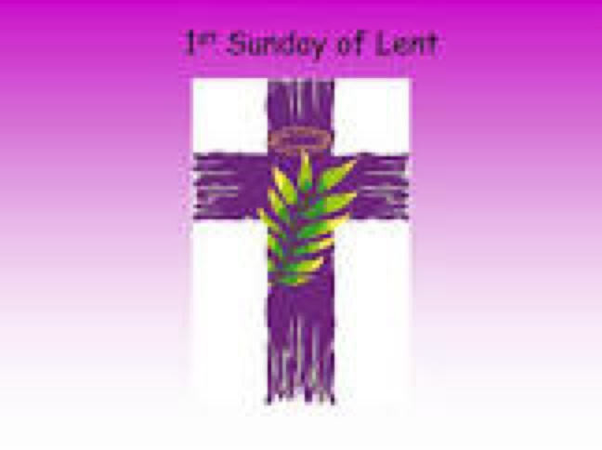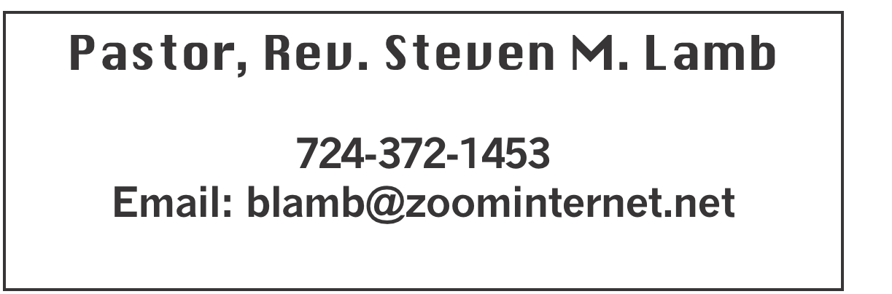

**\*\*\*\*\*\*\*\*\*\*\*\*\*\*\*\*\*\*\*\*\*\*\*\*\*\*\*\*\*\*\*\*\*\*\*\*\*\*\*\*\*\*\*\*\*\*\*\*\*\*\*\*\*\*\***

**March 9, 2025 Liturgist, Rick Tressler 10:45a.m.**

**First Sunday in Lent**

**\*\*\*\*\*\*\*\*\*\*\*\*\*\*\*\*\*\*\*\*\*\*\*\*\*\*\*\*\*\*\*\*\*\*\*\*\*\*\*\*\*\*\*\*\*\*\*\*\*\*\*\*\*\*\*\*\***

**WELCOME AND ANNOUNCEMENTS**

**PRELUDE “On A Rugged Hill” Whitford**

**BRINGING FORTH THE LIGHT**

**\*OPENING HYMN “‘Tis So Sweet to Trust in Jesus” 462**

**\*CALL TO WORSHIP**

**Psalm 91 - pages 810-811**

**\*OPENING PRAYER**

**God, you are our refuge: You are the shore in sight, you are hands that reach out, you are the ground on which to rest.**

**God, you are our strength: You are the life we long for, you are the refusal to give up, you are the keys of home we carry with us.**

**God, you are our help in time of trouble: We call on you from the ruins and the rubble, we call on you from the wildness and the deep,**

**We call on you to meet us in this place! Amen.**

**\*GLORIA PATRI 70**

**OLD TESTAMENT READING Deuteronomy 26:1-11**

**The word of God for the people of God. Thanks be to God**

**ANTHEM “Guide My Feet”**

**CHILDREN’S MOMENT & Coin offering**

**\*PASSING THE PEACE**

**OFFERING**

**OFFEERTORY “At The Cross” Smith**

**\*DOXOLOGY**

**\*OFFERTORY PRAYER**

**PRAYERS OFFERED IN PRAISE AND PETITION**

**PRAYER HYMN “My Faith Looks Up to Thee” 452**

**PASTORAL PRAYER**

**SILENT MEDITATION**

**LORD’S PRAYER**

**GOSPEL READING Luke 4:1-13**

**The word of God for the people of God. Thanks be to God.**

***Thy Word is a lamp unto my feet and a light unto my path***

**MESSAGE “Catching Chickens”**

**\*CLOSING HYMN “Trust and Obey” 467**

**\*BENEDICTION**

**\*POSTLUDE**

**\*\*\*\*\*\*\*\*\*\*\*\*\*\*\*\*\*\*\*\*\*\*\*\*\*\*\*\*\*\*\*\*\*\*\*\*\*\*\*\*\*\*\*\*\*\*\*\*\***

WELCOME

***We welcome you to this worship service on this first Sunday in Lent. May your Lenten journey be a time of growth in your faith. We hope to see you every Sunday in Lent.***

**PRAYER CONCERNS THIS WEEK**

**Don Heckathorne Ray Knopsnider Baby Thompson**

**Trey Corvin Larry Murray Jack Burke**

**Randy Jacobs Tina Hiltabidel Patty Lint**

**Scott Wagner Rick Miller Randy Fisher**

**John Shaw George Mariotti Mary Swope**

**Lee Mimless Lincoln Dunseth**  **Sandy Reich**

**Daniel Swope Rob Miller Wanda Brooks**

**Paula Shaffer Twila Filler Jeff Regish**

**Tom Dewhurst Carol Ward Peggy Chase**

**George Seighman Sue Capo Larry Bloom Sr.**

**Caitlin Pellick Jamey Klonowski Jeffrey Sarmelli**

**Carol Hunter Elton & Noah Schrock Liam Lewandowski**

**Susan Marietta Harper Grace & Connor Jay Schrin**

**Jason Mayer Jim Pennington Beth Lamb**

**Joyse Shaffer Wisaloski family Kim Welsh**

**Ron Barry Brenda Siple on death of sister**

**Baby Jessi (Jackie’s granddaughter) Emmalyn & Olivia Hixon**

**Judy Whipkey** Pastor Steve & Bev **Rev. Ross Pryor**

**Bishop Sandra Steiner Ball**

Homebound persons: **Edna Baker, Polly Basinger, Evelyn Curry, Sherrill Goodwin, Chuck Hall, Dolly King, Shirley Mathias, Stephanie Mattis, Ed Miller, Judy Morris,, Ozella Roy**

Unspoken Requests All Military All churches

Government leaders Folks with cancer Those traveling

Those battling addiction Folks on Hospice Homeless people

Praise for answered prayers Peace around the World

Those with flu Families of those who take their own life

If you want a name on prayer list, please use the

prayer cards in the pew - give to acolytes or ushers.

THIS WEEK AT ALBRIGHT

**TUESDAY: United Women in Faith meeting 7:00**

**WEDNESDAY: Bible study 6:30**

**THURSDAY: Choir practice 7:00**

**SATURDAY: Saturday Morning Special 11:00**

**Benefit pancake dinner 4-7 at Otterbein**

**SUNDAY: LAST DAY to order pies**

OFFICE HOURS: Tuesday, Wednesday, Thursday 10:00-3:00

PIE ORDERS

**We are taking orders for pies from the Pie Shoppe. Order forms are out near bltins. Need orders to Bev or the office by March 16. Pies can be picked up on Saturday, March 29.**

BENEFIT PANCAKE DINNER

*Saturday, March 15 at 4-7p.m. Otterbein church will have a pancake dinner to benefit Andrew Karwatsky who was badly injured in an accident recently. Cost is $12 adult; $6 age 4-12; age 3 & under eat free. Elsie & Bev have tickets.*

**CRAFT/VENDOR SHOW**

Sat., March 22 at 9:00-4:00. $25 first table; $15 for 2nd; $10 thereafter - non refundable. 1 vendor per type of product. Set up Friday 6-8 & Sat. 7-8:30 and will remain set up until 4:00. Applications available from Bev Lamb or in the office. ***Any questions, call Bev 724-372-1456 or church office 724-628-7130.***

CHURCH COUNCIL

**Will meet Tuesday, March 18 at 7:00 in dining hall.**

March Happenings

**Tues., 11th: United Women in Faith meeting 7:00**

**Sat., 15th: Saturday Morning Special 11:00**

**Sat., 15th: Pancake dinner 4-7 at Otterbein**

**Tues., 18th: Church council 7:00; News deadline for Apr/May**

**Sat., 22nd: Craft/Vendor Show 9-4; Our church selling food**

**Tues., 25th: Blue plate special 11-1**

**Sat., 29th: Pies can be picked up**

**Sun., 30th: Potluck covered dish after church**

**Every Thursday: Choir practice 7:00**

April Happenings

**Tues., 8th: United Women in Faith mtg. 7:00**

**Sat., 12th: Community Easter Dinner 4-7; Takeout $5**

**Sun., 13th: Pick up candy**

**Thurs., 17th: Holy Thursday worship 7:30 at Otterbein**

**Fri., 18th: Good Friday worship 7:30 at Albright**

**Sun., 20th: Sunrise svc. 7a.m. followed by breakfast-Alb.**

**Tues., 22: Blue plate special 11-1**

**Every Thursday: Choir practice 7:00**

OUR STEWARDSHIP - March 2

**Weekly need for budget ........................................... $ 2,491.56**

**Sunday offering......................................................... $ 2,345.00**

**Worship attendance ...................................................... 59**

**GREETING YOU TODAY: Jay & Judy Whipkey**

**March 16: Doris & Dustin Murray**

**LITURGIST: March 16: Nancy Mimless**

**March 23: Linda Burnworth**

**ACOLYTES TODAY: Kadey & Aubree Shaffer**

**March 16: Thelma Swope & Estella Gallagher**

**JUNIOR CHURCH TODAY: Kelli Armstrong & Nancy Mimless**

**March 16: Larry & Bonnie Bloom**

**USHERS: Larry Bloom, Scott Murray, Sally Fosbrink, Michelle Reich**

**Mar.16: Jay & Judy Whipkey, Linda Burnworth, Pinky Smiley**

**COUNTERS: March: Sally Fosbrink & Jackie Bartholomai**

**April: Karen Stimmell & Jay Whipkey**

FREE COMMUNITY EASTER DINNER

**Will be Saturday, April 12 at 4:00-7:00.**

**Call 724-628-7130 to pre-register. Eat in free. Take out available for $5 each.**

**REGISTRATION IS GREATLY APPRECIATED.**

APRIL/MAY NEWSLETTER

**News deadline is Tuesday, March 18.**

***PASTA MEAL***

**Thursday, March 20 at 4-6p.m. Otterbein will have their monthly pasta meal. Free with donations accepted. $5 for take out.**

TRIP TO SEE NOAH IN JUNE

Bev can still take reservations for this overnight trip June 20-21. See her if you are interested. She must know by the middle of April.