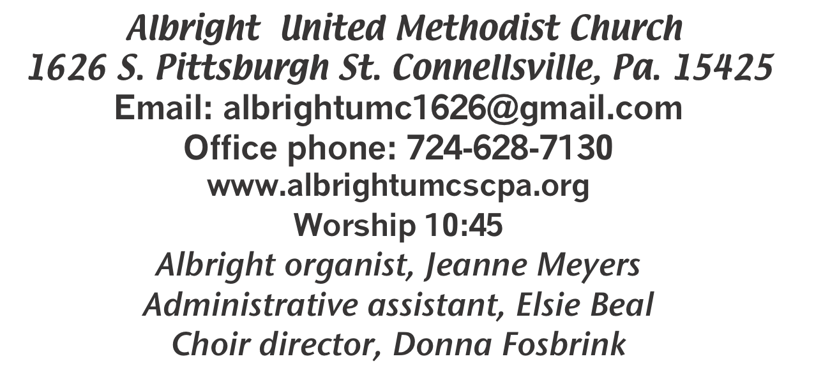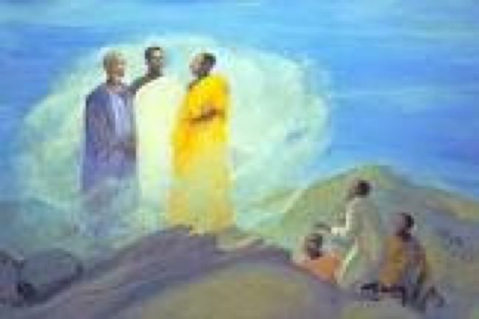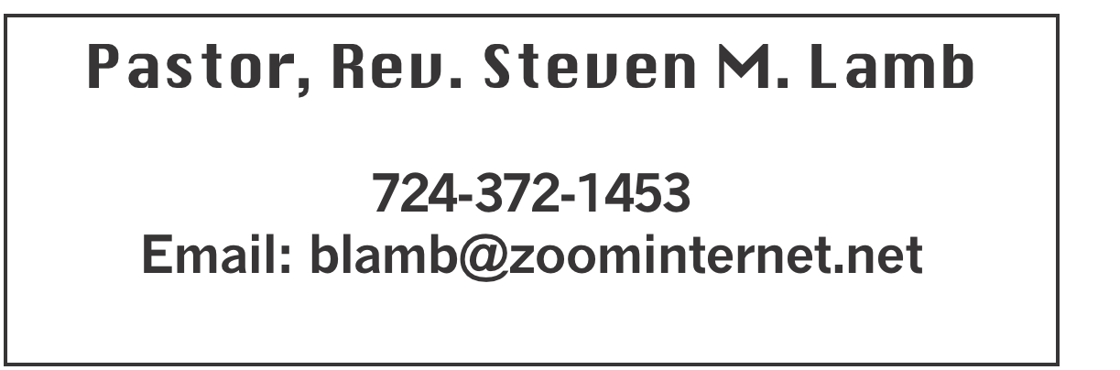

**\*\*\*\*\*\*\*\*\*\*\*\*\*\*\*\*\*\*\*\*\*\*\*\*\*\*\*\*\*\*\*\*\*\*\*\*\*\*\*\*\*\*\*\*\*\*\*\*\*\*\*\*\*\*\***

**March 2, 2025 Liturgist, Shelley Mattis 10:45a.m.**

**Transfiguration Sunday**

**\*\*\*\*\*\*\*\*\*\*\*\*\*\*\*\*\*\*\*\*\*\*\*\*\*\*\*\*\*\*\*\*\*\*\*\*\*\*\*\*\*\*\*\*\*\*\*\*\*\*\*\*\*\*\*\*\*\***

**WELCOME AND ANNOUNCEMENTS**

**PRELUDE “If That Isn’t Love” Rambo**

**BRINGING FORTH THE LIGHT**

**\*OPENING HYMN “O Wondrous Sight! O Vision Fair” 258**

**\*CALL TO WORSHIP**

**Leader: The blessing of God**

People: Rests on our shoulders.

**Leader: The love of God**

People: Dwells in our hearts.

**Leader: The word of God**

People: Inflames our speech.

**Leader: The compassion of God**

People: Stirs us to care.

**Leader: The word of God**

People: Compels us to sing.

**Leader: The mystery of God**

People: Leads us to worship.

**\*OPENING PRAYER**

**As we spend this hour together in the presence of our Holy God, may we remember that we are the face of Jesus to everyone we encounter. Help us to live and love as Jesus would. And may the world be changed because they have met Jesus face to face through us. Amen.**

**\*GLORIA PATRI 70**

**EPISTLE READING 2 Corinthians 3:12-4:2**

**The word of God for the people of God. Thanks be to God.**

**ANTHEM “Taste and See”**

**SERVICE OF HOLY COMMUNION**

**THE LORD’S PRAYER**

**CHILDREN’S MOMENT & Coin offering**

**PASSING THE PEACE**

**OFFERING**

**OFFERTORY “Near The Cross” Doane**

**\*DOXOLOGY**

**\*OFFERTORY PRAYER**

**PRAYERS OFFERED IN PRAISE AND PETITION**

**PRAYER HYMN “Christ Upon the Mountain Peak” 260**

**PASTORAL PRAYER**

**SILENT MEDITATION**

**GOSPEL READING Luke 9:28-36**

**The word of God for the people of God. Thanks be to God.**

***Thy Word is a lamp unto my feet and a light unto my path***

**MESSAGE “Listen to Jesus”**

**\*CLOSING HYMN “Turn Your Eyes Upon Jesus” 349**

**\*BENEDICTION**

**\*POSTLUDE**

**\*\*\*\*\*\*\*\*\*\*\*\*\*\*\*\*\*\*\*\*\*\*\*\*\*\*\*\*\*\*\*\*\*\*\*\*\*\*\*\*\*\*\*\*\*\*\*\*\*\***

**WELCOME**

***This week we will begin the season of Lent. We welcome you to this worship service and hope you find rest and peace this week and always.***

**PRAYER CONCERNS THIS WEEK**

**Don Heckathorne Ray Knopsnider Thomas Leeder Paul & Myra Holden Baby Thompson Becky Irwin James & Deanna Sherbondy Trey Corvin Paula Snyder Chadd Tressler**

**Larry Murray Jack Burke Randy Jacobs Tina Hiltabidel Patty Lint**

**Rev. Rob & Lynn Kifer Shannon Mack Scott Wagner Rick Miller Randy Fisher**

**John Shaw George Mariotti Mary Swope Lee Mimless Kathy Meyers**

**Sandy Fox Buzz & Barb Stuart Lincoln Dunseth**  **Sandy Reich Daniel Swope**

**Rob Miller Wanda Brooks Paula Shaffer Twila Filler Jeff Regish**

**Tom Dewhurst Carol Ward Kim Colosima Peggy Chase George Seighman**

**Sue Capo Larry Bloom Sr. Caitlin Pellick Jamey Klonowski Jeffrey Sarmelli**

**Jayden Sheffer Joseph Hall & family Richard Shipley Carol Hunter Elton & Noah Schrock**

**Liam Lewandowski Susan Marietta Harper Grace & Connor Jay Schrin Bonnie Foley** Pastor Steve & Bev  **Rev. Ross Pryor Bishop Sandra Steiner Ball**

**DEEPEST SYMPATHY TO FAMILY & FRIENDS OF:**

**Mariloyd McClintock, 87, who passed away Feb. 18.**

**James Lynn, who passed away Feb. 18.**

Homebound persons:  **Edna Baker, Polly Basinger, Evelyn Curry, Sherrill Goodwin, Chuck Hall, Dolly King, Shirley Mathias,**

**Stephanie Mattis, Ed Miller, Judy Morris, Ozella Roy**

Unspoken Requests All Military All churches

Government leaders Folks with cancer Those traveling

Those battling addiction Folks on Hospice Homeless people

Praise for answered prayers Peace around the World

Families of those who take their own life

If you want a name on prayer list, please use the prayer cards in the pew - give to acolytes or ushers.

**THIS WEEK AT ALBRIGHT**

**Ash Wednesday: Worship at Otterbein noon; at Albright 6:30**

**THURSDAY: Choir practice 7:00**

**FRIDAY: Sub sale 10-1 $12 each**

**SATURDAY: Sub sale & Homemade soup sale 10-1**

**Set clocks up 1 hour - Spring forward**

OFFICE HOURS**: Tuesday, Wednesday, Thursday 10:00-3:00**

PIE ORDERS

**We are taking orders for pies from the Pie Shoppe. Order forms are out near bltins. Need orders to Bev or the office by March 16. Pies can be picked up on Saturday, March 29.**

BENEFIT PANCAKE DINNER

*Saturday, March 15 at 4-7p.m. Otterbein church will have a pancake dinner to benefit Andrew Karwatsky who was badly injured in an accident recently. Cost is $12 adult; $6 age 4-12; age 3 & under eat free. Elsie & Bev have tickets.*

SUBS & SOUP SALE

**Friday, March 7 & Saturday, March 8 we will have a Sub sale.**

**12” subs ar $12 each. PLEASE order ahead to be sure you**

**get what you want. Use order forms out near bulletins.**

**Saturday, March 8 Final soup sale for this year. Eat in for a**

**donation. Take out $7 pint $9 quart. If you will donate soup,**

**please sign up on the form in back of the sanctuary.**

March Happenings

**Wed., 5th: Ash Wed.: Worship noon at Otterbein; 6:30 at Albright**

**Fri., 7th & Sat., 8th: Sub sale 10-1. $12 for 12” subs. Order ahead.**

**Sat., 8th: Soup sale 10:00-1:00; Turn clocks up 1 hour tonight**

**Tues., 11th: United Women in Faith meeting 7:00**

**Sat., 15th: Saturday Morning Special 11:00**

**Sat., 15th: Pancake dinner 4-7 at Otterbein**

**Tues., 18th: Church council 7:00; News deadline for Apr/May**

**Sat., 22nd: Craft/Vendor Show 9-4; Our church selling food**

**Tues., 25th: Blue plate special 11-1**

**Sat., 29th: Pies can be picked up**

**Sun., 30th: Potluck covered dish after church**

**Every Thursday: Choir practice 7:00**

April Happenings

**Tues., 8th: United Women in Faith mtg. 7:00**

**Sat., 12th: Community Easter Dinner 4-7; Takeout $5**

**Sun., 13th: Pick up candy**

**Thurs., 17th: Holy Thursday worship 7:30 at Otterbein**

**Fri., 18th: Good Friday worship 7:30 at Albright**

**Sun., 20th: Sunrise svc. 7a.m. followed by breakfast-Alb.**

**Tues., 22: Blue plate special 11-1**

**Every Thursday: Choir practice 7:00**

OUR STEWARDSHIP - February 23

**Weekly need for budget ........................................... $ 2,491.56**

**Sunday offering......................................................... $ 1,821.00**

**Worship attendance ...................................................... 70**

**GREETING YOU TODAY: Kelli Armstrong & Jeremy Gray**

**March 9: Jay & Judy Whipkey**

**LITURGIST: March 9: Rick Tressler**

**March 16: Nancy Mimless**

**ACOLYTES TODAY: Emmaleigh Kalemba & Thelma Swope**

**March 9: Kadey & Aubree Shaffer**

**JUNIOR CHURCH TODAY: Kathy Hixson & Linda Burnworth**

**March 9: Kelli Armstrong & Nancy Mimless**

**USHERS: Jackie Bartholomai, Jeremy Gray, Sherry Grote, Ed Jacobs**

**Mar. 9: Larry Bloom, Scott Murray, Sally Fosbrink, Michelle Reich**

**COUNTERS: March: Sally Fosbrink & Jackie Bartholomai**

**April: Karen Stimmell & Jay Whipkey**

ASH WEDNESDAY

**March 5: Worship noon at Otterbein; 6:30 at Albright. Hope to see you there as we begin the Lenten season.**

FREE COMMUNITY EASTER DINNER

**Will be Saturday, April 12 at 4:00-7:00.**

**Call 724-628-7130 to pre-register. Eat in free.**

**Take out available for $5 each.**

**REGISTRATION IS GREATLY APPRECIATED.**

**CRAFT/VENDOR SHOW**

Sat., March 22 at 9:00-4:00. $25 first table; $15 for 2nd; $10 thereafter - non refundable. 1 vendor per type of product. Set up Friday 6-8 & Sat. 7-8:30 and will remain set up until 4:00. Applications available from Bev Lamb or in the office. ***Any questions, call Bev 724-372-1456 or church office***

***724-628-7130.***

Spring Lay Servant School:

The Connellsville District is offering Lay School Ministry classes for the Spring 2025 session. Classes will be held on the following Sundays, March 9th, March 16th, March 23rd, March 30th and April 6th, 2025.

Location: Barren Run UMC, Barren Run Rd, Smithton PA .2:00 pm-5:00 pm, followed by closing service after the final class. Registration Deadline March 3rd. Costs $25.00 paid in advance.

Spring Course offerings are:

• Basic Course:- Rev. Charles Jack

• Life Together in the United Methodist Church (UMC Polity)- Rev. Ryan Washabaugh

• Teaching Biblical Faith- Leading Small Group Bible Studies -Rev. Kim Foos

• Called To Preach -Rev. Steve Lamb

• Confirmation Class-Open to all interested in church membership: -Deb Conn

------------------------------------------------------------------------

Breakthrough Prayer: Bishop Sandra Steiner Ball

invites you to join a Breakthrough Prayer Initiative this Lenten season, using the Dynamite Prayer

resource authored by Sue Nilson Kibbey and

Rosario Picardo. Join the connection in harnessing the strength of our Western Pennsylvania connection to experience this simple-yet-powerful way of praying, where we ask God to open new doors and reveal new possibilities for our Conference, fueled by the Spirit’s power.

**SUB SALE**

**Seller _______________________________ 12” Subs $12.00**

**Day Name Phone # How many Total Due Paid**

**1. ______________________________________________________________**

**2._______________________________________________________________**

**3._______________________________________________________________**

**4._______________________________________________________________**

**5._______________________________________________________________**

**6._______________________________________________________________**

**7._______________________________________________________________**

**8._______________________________________________________________**

**9._______________________________________________________________**

**10.______________________________________________________________**

**11.______________________________________________________________**

**12.______________________________________________________________**

**Orders due by March 2. May be picked up Fri., March 7 or Sat., March 8 @ 10-1 or until sold out at Albright UM Church.**