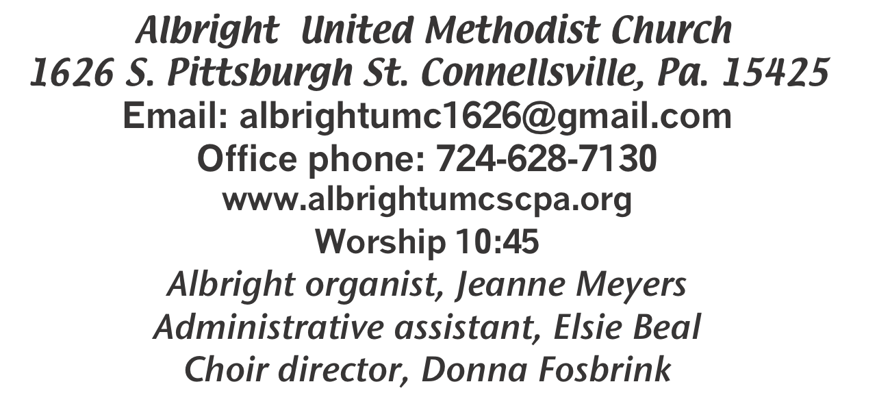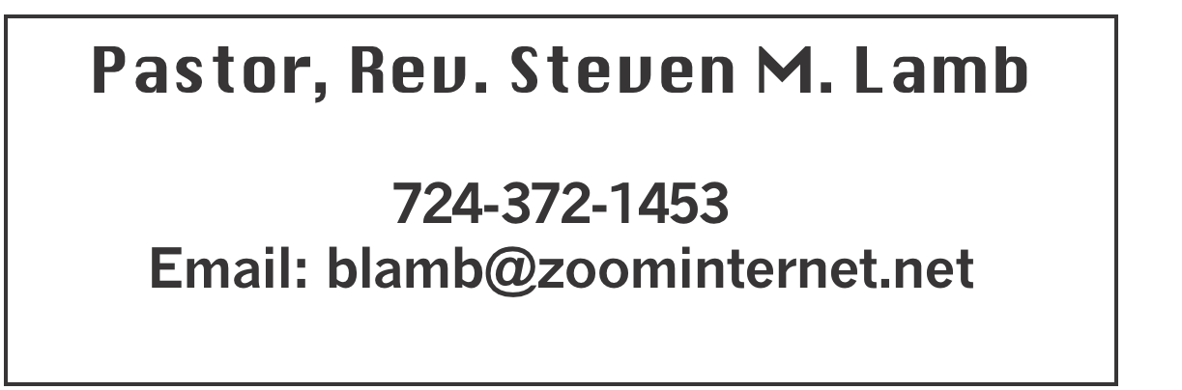

**\*\*\*\*\*\*\*\*\*\*\*\*\*\*\*\*\*\*\*\*\*\*\*\*\*\*\*\*\*\*\*\*\*\*\*\*\*\*\*\*\*\*\*\*\*\*\*\*\*\*\*\*\*\*\***

**February 9, 2025 Liturgist, Donna Fosbrink 10:45a.m.**

**WELCOME AND ANNOUNCEMENTS**

**PRELUDE “The Way That He Loves” Mercer**

**BRINGING FORTH THE LIGHT**

**\*OPENING HYMN “Rock of Ages” 361**

**\*CALL TO WORSHIP**

**L: God saves us.**

P: God calls us with a holy calling.

**L: God calls us according to his own purpose and grace.**

P: His grace has been revealed through the appearing of

our Savior Jesus Christ.

**L: For us, our Savior abolished death and brought life**

**and immortality to light.**

P: We have been appointed heralds for this gospel.

**L: We know in whom we have put our trust.**

P: We shall guard the good treasure entrusted to us.

**\*OPENING PRAYER**

**God has not forgotten you. Lord, thank You for your nearness even when I don’t feel it. I want to feel it!**

**Help me tune in, and listen for Your whispers, and wait well with the expectation that You will remember me. Amen.**

**\*GLORIA PATRI 70**

**NEW TESTAMENT READING Matthew 6:6-8**

**The word of God for the people of God. Thanks be to God**

**ANTHEM “Peace, Be Still”**

**CHILDREN’S MOMENT & Coin offering**

**\*PASSING THE PEACE**

**OFFERING**

**OFFEERTORY “I Could Never Outlove the Lord” Gaither**

**\*DOXOLOGY**

**\*OFFERTORY PRAYER**

**PRAYERS OFFERED IN PRAISE AND PETITION**

**PRAYER HYMN “Take Time to Be Holy” 395**

**PASTORAL PRAYER**

**SILENT MEDITATION**

**LORD’S PRAYER**

**GOSPEL READING Isaiah 49:15-16**

**The word of God for the people of God. Thanks be to God.**

***Thy Word is a lamp unto my feet and a light unto my path***

**MESSAGE “Have you ever felt like God has forgotten about you?”**

**Fred Grote, speaker**

**\*CLOSING HYMN“Stand Up, Stand Up for Jesus” 514**

**\*BENEDICTION**

**\*POSTLUDE**

**\*\*\*\*\*\*\*\*\*\*\*\*\*\*\*\*\*\*\*\*\*\*\*\*\*\*\*\*\*\*\*\*\*\*\*\*\*\*\*\*\*\*\*\*\*\*\*\*\***

WELCOME

***Welcome to worship. Join us in singing our praises to God. Let us share in Christian worship and fellowship as brothers and sisters in Christ.***

**PRAYER CONCERNS THIS WEEK**

**Don Heckathorne Ray Knopsnider Thomas Leeder**

**Paul & Myra Holden Baby Thompson Becky Irwin**

**James & Deanna Sherbondy Trey Corvin Paula Snyder**

**Allen Mellinger Chadd Tressler Larry Murray**

**Jack Burke Bobby Kozel Randy Jacobs**

**Tina Hiltabidel Rev. Rob & Lynn Kifer Shannon Mack**

**Patty Lint Scott Wagner Rick Miller**

**Randy Fisher John Shaw George Mariotti**

**Mary Swope Lee Mimless Kathy Meyers**

**Sandy Fox Buzz & Barb Stuart Lincoln Dunseth**

**Sandy Reich Rob Miller Pete Darno**

**James Lynn Judy Eversdyke Wanda Brooks**

**Susan Ramage Daniel Swope Jr. Twila Filler**

**Jeff Regish Tom Dewhurst Carol Ward**

**Kim Colosima Peggy Chase George Seighman**

**Caitlin Pellick Jamey Klonowski Sue Capo**

**Harper Grace & Connor Jay Schrin Elton & Noah Schrock**

**Liam Lewandowski Families of those killed in plane crashes**

Pastor Steve & Bev **Rev. Ross Pryor**

**Bishop Sandra Steiner Ball**

Homebound persons: **Edna Baker, Polly Basinger, Evelyn**

**Curry, Sherrill Goodwin, Chuck Hall, Dolly King, Jimmy Lynn, Shirley Mathias, Stephanie Mattis, Mariloyd McClintock, Ed Miller, Judy Morris,, Ozella Roy**

Unspoken Requests All Military All churches

Government leaders Folks with cancer Those traveling

Those battling addiction Folks on Hospice Homeless people

Praise for answered prayers Peace around the World

Families of those who take their own life

If you want a name on prayer list, please use the prayer cards in the pew - give to acolytes or ushers.

THIS WEEK AT ALBRIGHT

**TODAY: Donations for local food pantry**

**WEDNESDAY: Bible study 6:30**

**THURSDAY: Choir practice 7:00**

**SATURDAY: Sweetheart breakfast cooked by men 9:00**

OFFICE HOURS: Tuesday, Wednesday, Thursday 10:00-3:00

(weather permitting) Office phone 724-628-7130

Elsie at home 742-628-7467

SWEETHEART BREAKFAST

**Saturday, February 15 at 9:00 will be our annual sweetheart breakfast. The men will cook for the ladies of the church. Even if you don’t have a sweetheart, come and enjoy the meal and the fellowship.**

February Happenings

**Sun., Feb. 9: Super Bowl Sunday - Donations for Food Pantry**

**Thurs., Feb. 20: Pasta meal 4-6 at Otterbein**

**Tues., Feb. 25: Blue Plate Special 11:00-1:00**

**Every Thursday at 7:00 Choir practice**

March Happenings

**Wed., 5th: Ash Wed.: Worship noon at Otterbein; 6:30 at Albright**

**Sat., 8th: Soup sale 10:00-1:00;**

**Turn clocks up 1 hour tonight**

**Tues., 11th: United Women in Faith meeting 7:00**

**Sat., 15th: Saturday Morning Special 11:00**

**Tues., 18th: Church council 7:00; News deadline for Apr/May**

**Thurs., 20th: Pasta meal 4-6 at Otterbein**

**Sat., 22nd: Craft/Vendor Show 9-4; Our church selling food**

**Tues., 25th: Blue plate special 11-1**

**Sun., 30th: Potluck covered dish after church**

**Every Thursday: Choir practice 7:00**

***PASTA MEAL***

**Thursday, February 20 at 4:00-6:00. Free pasta meal at Otterbein UM Church. Donations accepted. $5 for take out.**

BLUE PLATE SPECIAL

**Tuesday, Feb. 25 at 11:00-1:00. Free with donations accepted. $5 for take out.**

***2025 CHURCH DIRECTORY***

**New directories are out in the back of the sanctuary. Cost is $1.25 each to cover the cost of printing.**

2024 STATEMENTS OF GIVING

Are out in the sanctuary. Please take them.

OUR STEWARDSHIP - February 2

**Weekly need for budget ........................................... $ 2,491.56**

**Sunday offering......................................................... $ 2,685.00**

**(2 weeks coin offering $94.00)**

**Worship attendance ...................................................... 63**

General Fund balance as of Jan. 1...... Minus - $25,121.24

Monthly need is $10, 506.38

NOVEMBER income for the month $8,013.00

DECEMBER income for the month $12,905.02 (5 Suns.)

WE NEED YOUR HELP & SUPPORT!

**GREETING YOU TODAY: Pamela Lynn**

**Feb. 16:Michelle Reich**

**LITURGIST: Feb. 16: Bev Lamb**

**Feb. 23: Emma Karfelt**

**ACOLYTES TODAY: Estella Gallagher & Thelma Swope**

**Feb. 16: Beau Wagner & Andrew Lynn**

**JUNIOR CHURCH TODAY: Kelli Armstrong & Nancy Mimless**

**Feb. 16: Larry & Bonnie Bloom**

**USHERS: Larry Bloom, Scott Murray, Sally Fosbrink, Michelle Reich**

**Feb. 16:Jay & Judy Whipkey, Linda Burnworth, Pinky Smiley**

**COUNTERS: February: Linda Burnworth & Jay Whipkey**

**March: Sally Fosbrink & Jackie Bartholomai**

**CRAFT/VENDOR SHOW**

Sat., March 22 at 9:00-4:00. $25 first table; $15 for 2nd; $10 thereafter - non refundable. Money due Feb. 20. 1 vendor per type of product. Set up Friday 6-8 & Sat. 7-8:30 and will remain set up until 4:00. Applications available from Bev Lamb or in the office.

FREE COMMUNITY EASTER DINNER

**Will be Saturday, April 12 at 4:00-7:00. Call 724-628-7130 to pre-register. Eat in free. Take out available for $5 each. REGISTRATION IS GREATLY APPRECIATED.**