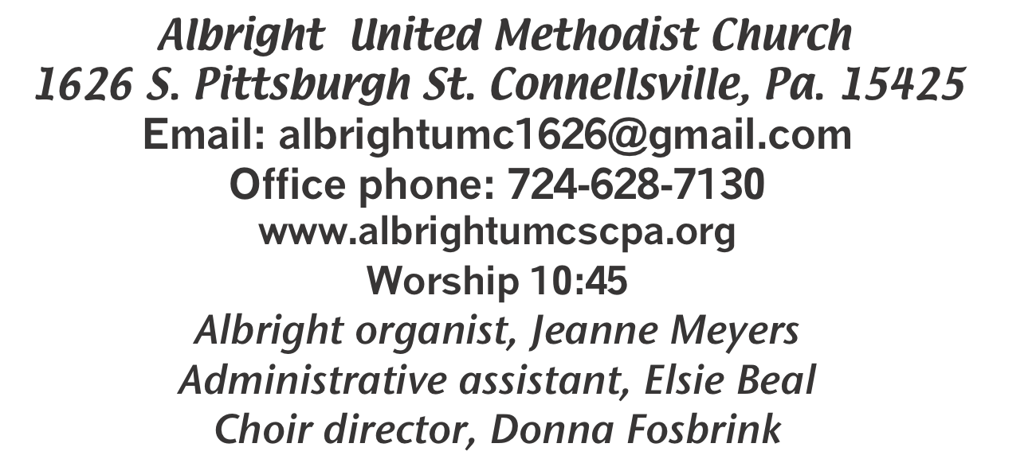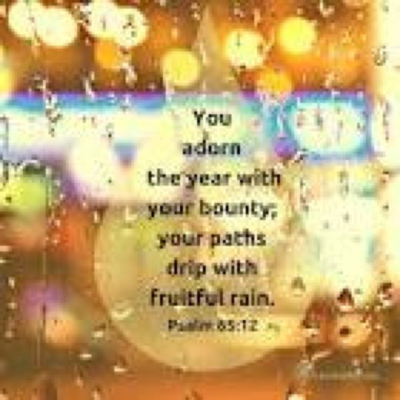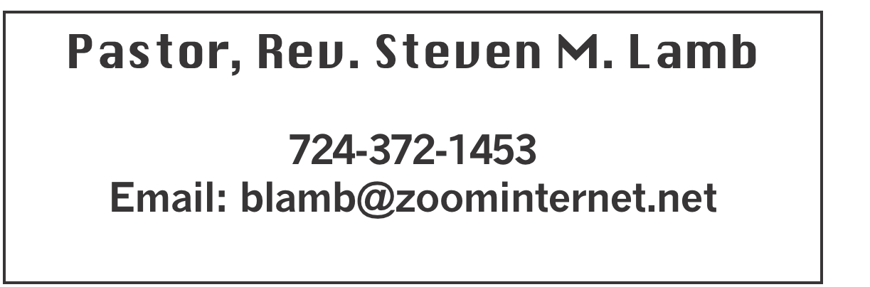

**\*\*\*\*\*\*\*\*\*\*\*\*\*\*\*\*\*\*\*\*\*\*\*\*\*\*\*\*\*\*\*\*\*\*\*\*\*\*\*\*\*\*\*\*\*\*\*\*\*\*\*\*\*\*\***

**February 23, 2025 Liturgist, Emma Karfelt 10:45a.m.**

**\*\*\*\*\*\*\*\*\*\*\*\*\*\*\*\*\*\*\*\*\*\*\*\*\*\*\*\*\*\*\*\*\*\*\*\*\*\*\*\*\*\*\*\*\*\*\*\*\*\*\*\*\*\*\*\***

**WELCOME AND ANNOUNCEMENTS**

**PRELUDE “I Know A Man Who Can” Campbell & Davis**

**BRINGING FORTH THE LIGHT**

**\*OPENING HYMN “Lst There Be Peace on Earth” 431**

**\*CALL TO WORSHIP**

**L: Holy God, we have heard, but not really taken to heart**

**the teachings of your Son. We find even the golden rule**

**hard to obey. As for turning the other cheek or walking**

**a second mile, we prefer to pretend that your Son could**

**not possibly have meant what he said. But we know that he**

**meant it, every word of it.**

P: Help us, patient and forgiving God, to take Jesus at his word.

Let him teach us how to live a life worth living. Let him show

us how to die a death worth dying.

***All: We pray, with penitence, in his name. Amen***

**\*OPENING PRAYER**

**Almighty God, Creator of the universe, Sustainer of life, Redeemer of the world, we are awed that a God of such majesty and mystery receives our worship, hears our prayers and cares for our concerns and burdens. We turn our hearts to you in this time and place to be reoriented to the truths of faith: that there is more to life than what we can see and touch; that love can conquer hate; that forgiveness of one’s enemies is not only possible but a mandate. We embrace the truth that hope is found in Jesus Christ, not in our retirement accounts, and that the foundation of life rests on you, not on us. Thank you, Lord, for meeting us here. We pray for your Spirit to speak to us and renew us by your grace. Amen.**

**\*GLORIA PATRI 70**

**OLD TESTAMENT READING Genesis 45:3-11, 15**

**The word of God for the people of God. Thanks be to God.**

**ANTHEM “A Psalm of Hope”**

**CHILDREN’S MOMENT & Coin Offering**

**PASSING THE PEACE**

**OFFERING**

**OFFERTORY “Blessed Assurance” Crosby**

**\*DOXOLOGY**

**\*OFFERTORY PRAYER**

**PRAYERS OFFERED IN PRAISE AND PETITION**

**PRAYER HYMN “I Can Hear My Savior Calling” 338**

**PASTORAL PRAYER**

**SILENT MEDITATION**

**THE LORD’S PRAYER**

**GOSPEL READING Luke 6:27-38**

**The word of God for the people of God. Thanks be to God.**

***Thy Word is a lamp unto my feet and a light unto my path***

**MESSAGE “In Each Other’s Shadow” of**

**“What’s So Golden About the Golden Rule?”**

**\*CLOSING HYMN “Grace Greater Than Our Sins” 365**

**\*BENEDICTION**

**\*POSTLUDE**

**\*\*\*\*\*\*\*\*\*\*\*\*\*\*\*\*\*\*\*\*\*\*\*\*\*\*\*\*\*\*\*\*\*\*\*\*\*\*\*\*\*\*\*\*\*\*\*\*\***

WELCOME

***We welcome those who have come to warm their hearts with the word of the Lord in this cold time of year. We pray the blessing you receive will stay with you this week until we meet again next Sunday.***

**PRAYER CONCERNS THIS WEEK**

**Don Heckathorne Ray Knopsnider Thomas Leeder Paul & Myra Holden Baby Thompson**

**Becky Irwin James & Deanna Sherbondy Trey Corvin Paula Snyder Chadd Tressler Larry Murray Jack Burke Bobby Kozel Randy Jacobs Tina Hiltabidel Rev. Rob & Lynn Kifer Shannon Mack Patty Lint Scott Wagner Rick Miller**

**Randy Fisher John Shaw George Mariotti Mary Swope Lee Mimless**

**Kathy Meyers Sandy Fox Buzz & Barb Stuart Lincoln Dunseth**  **Sandy Reich**

**Rob Miller Pete Darno James Lynn Judy Eversdyke Wanda Brooks**

**Daniel Swope Jr. Twila Filler Jeff Regish Tom Dewhurst Carol Ward**

**Kim Colosima Peggy Chase George Seighman Sue Capo Larry Bloom**

**Caitlin Pellick Jamey Klonowski Jeffrey Sarmelli Elton & Noah Schrock Liam Lewandowski**

**Harper Grace & Connor Jay Schrin Mariloyd McClintock Jayden Shaffer Susan Marietta**

Pastor Steve & Bev **Rev. Ross Pryor Bishop Sandra Steiner Ball**

**DEEPEST SYMPATHY TO FAMILY & FRIENDS OF:**

**Allen Mellinger, 52, who passed away January 29.**

**Susan Ramage, 53, who passed away February 12.**

**Jeffrey Karfelt, 62, who passed away February 13.**

**Adam Petrone, 44, who passed away February 14.**

Homebound persons: **Edna Baker, Polly Basinger, Evelyn Curry, Sherrill Goodwin, Chuck Hall, Dolly King, Jimmy Lynn, Shirley Mathias, Stephanie Mattis, Mariloyd**

**McClintock, Ed Miller, Judy Morris, Ozella Roy**

Unspoken Requests All Military All churches

Government leaders Folks with cancer Those traveling

Those battling addiction Folks on Hospice Homeless people

Praise for answered prayers Peace around

the World

Families of those who take their own life

**THIS WEEK AT ALBRIGHT**

**TUESDAY: Blue Plate Special 11:00-1:00**

**THURSDAY: Choir practice 7:00**

OFFICE HOURS: Tuesday, Wednesday, Thursday 10-3

(weather permitting) Office phone 724-628-7130

Elsie at home 742-628-7467

BLUE PLATE SPECIAL

**Tuesday, Feb. 25 at 11:00-1:00. Free with donations accepted. $5 for take out.**

PIE ORDERS

**We are taking orders for pies from the Pie Shoppe.**

**Order forms are out near bulletins. We need orders to Bev or in to the office by March 16. They can be picked up on Saturday, March 29.**

SUBS & SOUP SALE

**Friday, March 7 & Saturday, March 8 we will have a Sub sale. 12” subs ar $12 each. PLEASE order ahead to be sure you get what you want. Use order forms out near bulletins.**

**Saturday, March 8 Final soup sale for this year. Eat in for a donation. Take out $7 pint $9 quart. If you will donate soup, please sign up on the form in back of the sanctuary.**

March Happenings

**Wed., 5th: Ash Wed.: Worship noon at Otterbein; 6:30 at Albright**

**Fri., 7th & Sat., 8th: Sub sale 10-1. $12 for 12” subs. Order ahead.**

**Sat., 8th: Soup sale 10:00-1:00;**

**Turn clocks up 1 hour tonight**

**Tues., 11th: United Women in Faith meeting 7:00**

**Sat., 15th: Saturday Morning Special 11:00**

**Tues., 18th: Church council 7:00**

**News deadline for Apr/May**

**Sat., 22nd: Craft/Vendor Show 9-4; Our church selling food**

**Tues., 25th: Blue plate special 11-1**

**Sun., 30th: Potluck covered dish after church**

**Every Thursday: Choir practice 7:00**

**CRAFT/VENDOR SHOW**

Sat., March 22 at 9:00-4:00. $25 first table; $15 for 2nd; $10 thereafter - non refundable. 1 vendor per type of product. Set up Friday 6-8 & Sat. 7-8:30 and will remain set up until 4:00. Applications available from Bev Lamb or in the office. ***Any questions, call Bev 724-372-1456 or church office 724-628-7130.***

OUR STEWARDSHIP - February 16

**Weekly need for budget ........................................... $ 2,491.56**

**Sunday offering......................................................... $ 1,293.00**

**Worship attendance ...................................................... 62**

**GREETING YOU TODAY: Linda Burnworth**

**March 2: Kelli Armstrong & Jeremy Gray**

**LITURGIST: March 2: Shelley Mattis**

**March 9: Rick Tressler**

**ACOLYTES TODAY: Keelan & Kayton Callahan**

**March 2: Emmaleigh Kalemba & Thelma Swope**

**JUNIOR CHURCH TODAY: David & Shelley Mattis**

**March 2: Kathy Hixson & Linda Burnworth**

**USHERS: Jeremy Gray, Scott Murray, Ed Jacobs, Larry Bloom**

**Mar. 2: Jackie Bartholomai, Jeremy Gray, Sherry Grote, Ed Jacobs**

**COUNTERS: February: Linda Burnworth & Jay Whipkey**

**March: Sally Fosbrink & Jackie Bartholomai**

ASH WEDNESDAY

**March 5: Worship at noon at Otterbein and**

**6:30 at Albright. This is an important day which begins our journey of Lent.**

FREE COMMUNITY EASTER DINNER

**Will be Saturday, April 12 at 4:00-7:00.**

**Call 724-628-7130 to pre-register. Eat in free. Take out available for $5 each.**

**REGISTRATION IS GREATLY APPRECIATED.**

TRIP TO NOAH’S ARK IN LANCASTER

**Bev still has a couple of tickets available. Please see her as soon as possible if you are interested.**

SUMMER FARMER’S MARKETS

**A schedule of when the Farmer’s Markets are is posted in back of sanctuary and in the hallway on bulletin board.**

Spring Lay Servant School:

The Connellsville District is offering Lay School Ministry classes for the Spring 2025 session. Classes will be held on the following Sundays, March 9th, March 16th, March 23rd, March 30th and April 6th, 2025.

Location: Barren Run UMC, Barren Run Rd, Smithton PA .2:00 pm-5:00 pm, followed by closing service after the final class. Registration Deadline March 3rd. Costs $25.00 paid in advance.

Spring Course offerings are:

• Basic Course:- Rev. Charles Jack

• Life Together in the United Methodist Church (UMC Polity)- Rev. Ryan Washabaugh

• Teaching Biblical Faith- Leading Small Group Bible Studies -Rev. Kim Foos

• Called To Preach -Rev. Steve Lamb

• Confirmation Class-Open to all interested in church membership: -Deb Conn

------------------------------------------------------------------------

Breakthrough Prayer: Bishop Sandra Steiner Ball

invites you to join a Breakthrough Prayer Initiative this Lenten season, using the Dynamite Prayer

resource authored by Sue Nilson Kibbey and

Rosario Picardo. Join the connection in harnessing the strength of our Western Pennsylvania connection to experience this simple-yet-powerful way of praying, where we ask God to open new doors and reveal new possibilities for our Conference, fueled by the Spirit’s power.

------------------------------------------------------------------------

Otterbein will be serving a pancake dinner on March 15th from 4 to 7 PM. Details will be following shortly.