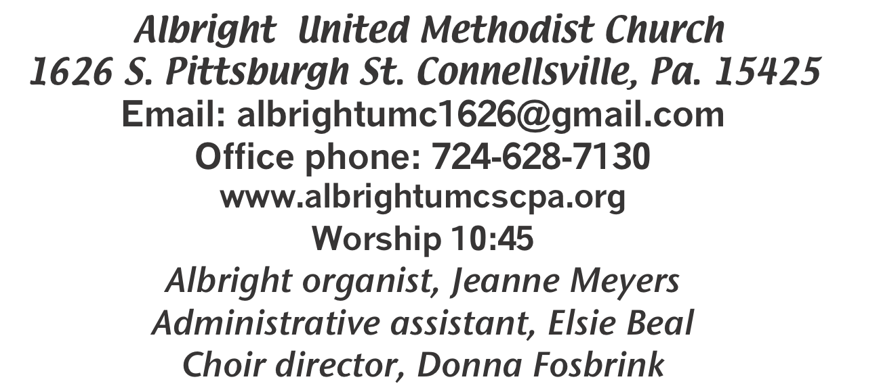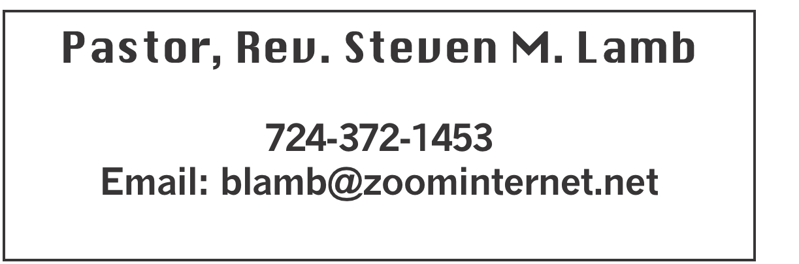

**\*\*\*\*\*\*\*\*\*\*\*\*\*\*\*\*\*\*\*\*\*\*\*\*\*\*\*\*\*\*\*\*\*\*\*\*\*\*\*\*\*\*\*\*\*\*\*\*\*\*\*\*\*\*\***

**February 16, 2025 Liturgist, Bev Lamb 10:45a.m.**

**\*\*\*\*\*\*\*\*\*\*\*\*\*\*\*\*\*\*\*\*\*\*\*\*\*\*\*\*\*\*\*\*\*\*\*\*\*\*\*\*\*\*\*\*\*\*\*\*\*\*\*\*\*\*\*\***

**WELCOME AND ANNOUNCEMENTS**

**PRELUDE “I Never Knew How it Felt” Tripp**

**BRINGING FORTH THE LIGHT**

**\*OPENING HYMN “Hymn of Promise” 707**

**\*CALL TO WORSHIP**

**L: Everyone come, come and refresh without money and**

**without price.**

P: Our hunger is not slight. We thirst for harmony and hunger

for integrity.

**L: Listen together for we have words of life. Your yearning**

**shall be filled, our longing shall be touched.**

P: For there is a promise: “My love for you shall be as for David.

Listening, you shall have good food and abundance.”

***All: Gracious God, who has satisfied the hungry and***

***quenched the thirst of longing people: Grant us now the gift***

***of attentiveness, that our eyes may see the favor of your***

***love. Grant us quickness of imagination, that we may see***

***the signals of your promise. Grant us warmth of heart,***

***that companionship may bind all within this house in***

***peace and love so that we may enjoy your wonder and***

***grace. For the sake of Christ, we pray, and for the sake of***

***all humankind. Amen.***

**\*OPENING PRAYER**

**O God, we thank you that you have called us your children. We are thankful for your provision, your guidance and your unending love for us. As your children, help us to listen and obey. Keep us from thinking we can live in our own power and strength. Just as children depend on their parents for food and shelter, let us depend on you for all that we need. You know us better than we know ourselves. Let us rest in that truth and live in the joy of being the children of God! Amen.**

**\*GLORIA PATRI 70**

**EPISTLE READING I Corinthians 15:12-20**

**The word of God for the people of God. Thanks be to God**

**ANTHEM “Soon and Very Soon”**

**CHILDREN’S MOMENT & Coin offering**

**PASSING THE PEACE**

**OFFERING**

**OFFERTORY “Just As I Am” Bradbury**

**\*DOXOLOGY**

**\*OFFERTORY PRAYER**

**PRAYERS OFFERED IN PRAISE AND PETITION**

**PRAYER HYMN “Are Ye Able” 530**

**PASTORAL PRAYER**

**SILENT MEDITATION**

**THE LORD’S PRAYER**

**OLD TESTAMENT READING Jeremiah 17:5-10**

**The word of God for the people of God. Thanks be to God.**

***Thy Word is a lamp unto my feet and a light unto my path***

**MESSAGE “What’s In Your Heart?”**

**\*CLOSING HYMN“God Be With You till We Meet Again” 672**

**\*BENEDICTION**

**\*POSTLUDE**

**\*\*\*\*\*\*\*\*\*\*\*\*\*\*\*\*\*\*\*\*\*\*\*\*\*\*\*\*\*\*\*\*\*\*\*\*\*\*\*\*\*\*\*\*\*\*\*\*\*\*\*\***

WELCOME

***We welcome every one who has come to worship our Lord and Savior with us today. We pray you will be blessed and will come again next Sunday.***

**PRAYER CONCERNS THIS WEEK**

**Don Heckathorne Ray Knopsnider Thomas Leeder Paul & Myra Holden Baby Thompson Becky Irwin James & Deanna Sherbondy Trey Corvin Paula Snyder Allen Mellinger Chadd Tressler Larry Murray Jack Burke Bobby Kozel Randy Jacobs**

**Tina Hiltabidel Rev. Rob & Lynn Kifer Shannon Mack Patty Lint Scott Wagner**

**Rick Miller Randy Fisher John Shaw George Mariotti Mary Swope**

**Lee Mimless Kathy Meyers Sandy Fox Buzz & Barb Stuart Lincoln Dunseth**

**Sandy Reich Rob Miller Pete Darno James Lynn Judy Eversdyke**

**Wanda Brooks Susan Ramage Daniel Swope Jr. Twila Filler Jeff Regish**

**Tom Dewhurst Carol Ward Kim Colosima Peggy Chase George Seighman**

**Caitlin Pellick Jamey Klonowski Sue Capo Harper Grace & Connor Jay Schrin**

**Elton & Noah Schrock Liam Lewandowski Larry Bloom Mariloyd McClintock**

**Susan Marietta** Pastor Steve & Bev **Rev. Ross Pryor Bishop Sandra Steiner Ball**

Homebound persons: **Edna Baker, Polly Basinger, Evelyn**

**Curry, Sherrill Goodwin, Chuck Hall, Dolly King, Jimmy Lynn, Shirley Mathias, Stephanie Mattis, Mariloyd McClintock, Ed Miller, Judy Morris,, Ozella Roy**

Unspoken Requests All Military All churches

Government leaders Folks with cancer Those traveling

Those battling addiction Folks on Hospice Homeless people

Praise for answered prayers Peace around the World

Families of those who take their own life

**If you want a name on prayer list, please use the prayer cards in the pew - give to acolytes or ushers.**

THIS WEEK AT ALBRIGHT

**THURSDAY: Pasta meal 4-6 at Otterbein**

**Money due today for craft/vendor show in March**

**Choir practice 7:00**

OFFICE HOURS**: Tuesday, Wednesday, Thursday 10:00-3:00**

(weather permitting) Office phone 724-628-7130

Elsie at home 742-628-7467

***PASTA MEAL***

**Thursday, February 20 at 4:00-6:00. Free pasta meal at Otterbein UM Church. Donations accepted. $5 for take out.**

BLUE PLATE SPECIAL

**Tuesday, Feb. 25 at 11:00-1:00. Free with donations accepted. $5 for take out.**

***2025 CHURCH DIRECTORY***

**New directories are out in the back of the sanctuary. Cost is $1.25 each to cover the cost of printing**

February Happenings

**Thurs., Feb. 20: Pasta meal 4-6 at Otterbein**

**Tues., Feb. 25: Blue Plate Special 11:00-1:00**

**Every Thursday at 7:00 Choir practice**

March Happenings

**Wed., 5th: Ash Wed.: Worship noon at Otterbein; 6:30 at Albright**

**Sat., 8th: Soup sale 10:00-1:00;**

**Turn clocks up 1 hour tonight**

**Tues., 11th: United Women in Faith meeting 7:00**

**Sat., 15th: Saturday Morning Special 11:00**

**Tues., 18th: Church council 7:00**

**News deadline for Apr/May**

**Thurs., 20th: Pasta meal 4-6 at Otterbein**

**Sat., 22nd: Craft/Vendor Show 9-4; Our church selling food**

**Tues., 25th: Blue plate special 11-1**

**Sun., 30th: Potluck covered dish after church**

**Every Thursday: Choir practice 7:00**

**CRAFT/VENDOR SHOW**

Sat., March 22 at 9:00-4:00. $25 first table; $15 for 2nd; $10 thereafter - non refundable.

Money due Feb. 20.

1 vendor per type of product. Set up Friday 6-8 & Sat. 7-8:30 and will remain set up until 4:00. Applications available from Bev Lamb or in the office. There are applications out in back of sanctuary. Any questions, call Bev 724-372-1456 or church office 724-628-7130.

OUR STEWARDSHIP - February 9

**Weekly need for budget ........................................... $ 2,491.56**

**Sunday offering......................................................... $ 2,289.25**

**Worship attendance ...................................................... 63**

**GREETING YOU TODAY: Michelle Reich**

**Feb. 23: Linda Burnworth**

**LITURGIST: Feb. 23: Emma Karfelt**

**March 2: Shelley Mattis**

**ACOLYTES TODAY: Beau Wagner & Andrew Lynn**

**Feb. 23: Keelan & Kayton Callahan**

**JUNIOR CHURCH TODAY: Larry & Bonnie Bloom**

**Feb. 23: David & Shelley Mattis**

**USHERS: Jay & Judy Whipkey, Linda Burnworth, Pinky Smiley**

**Feb. 23: Jeremy Gray, Scott Murray, Ed Jacobs, Larry Bloom**

**COUNTERS: February: Linda Burnworth & Jay Whipkey**

**March: Sally Fosbrink & Jackie Bartholomai**

ASH WEDNESDAY

**March 5: Worship at noon at Otterbein and**

**6:30 at Albright. This is an important day**

**which begins our journey of Lent.**

FREE COMMUNITY EASTER DINNER

**Will be Saturday, April 12 at 4:00-7:00.**

**Call 724-628-7130 to pre-register. Eat in free. Take out available for $5 each.**

**REGISTRATION IS GREATLY APPRECIATED.**

SUMMER FARMER’S MARKETS

**A schedule of when the Farmer’s Markets are is posted in back of sanctuary and in the hallway on bulletin board.**