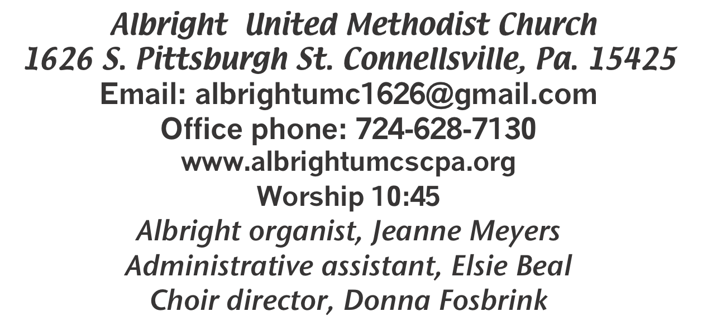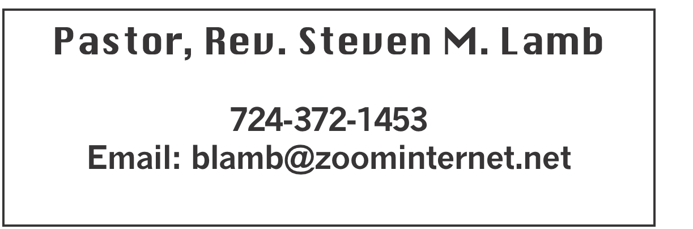

**\*\*\*\*\*\*\*\*\*\*\*\*\*\*\*\*\*\*\*\*\*\*\*\*\*\*\*\*\*\*\*\*\*\*\*\*\*\*\*\*\*\*\*\*\*\*\*\*\*\*\*\*\*\*\***

**January 19, 2025 Liturgist, Eve Shupe 10:45a.m.**

**\*\*\*\*\*\*\*\*\*\*\*\*\*\*\*\*\*\*\*\*\*\*\*\*\*\*\*\*\*\*\*\*\*\*\*\*\*\*\*\*\*\*\*\*\*\*\*\*\*\*\*\*\*\*\*\***

**WELCOME AND ANNOUNCEMENTS**

**PRELUDE “Tears Are A Language” Jensen**

**BRINGING FORTH THE LIGHT**

**\*OPENING HYMN “Standing on the Promises” 374**

**\*CALL TO WORSHIP**

**L: Lord Jesus, here we are to worship and praise you.**

P: Lord, you clothe the lilies, you feed the birds of the sky.

**L: You lead the lambs to pasture.**

P: Lord Jesus, here we are to worship and praise you**.**

**L: You lead the deer to the waterside.**

P: You multiplied loaves and fishes,

**L: And changed water into wine.**

P: Here, now, change and transform our lives.

**L: Remind us, Lord Jesus, that when we live in you,**

P: We are new people — new beings — filled with your love!

**\*OPENING PRAYER**

**Almighty God, you continually call your people to yourself, draw us by the power of your Holy Spirit into such a warm and binding relationship that we may faithfully follow you in all the days of our lives. We pray in the name of Jesus Christ. Amen.**

**\*GLORIA PATRI 70**

**OLD TESTAMENT READING Isaiah 62:1-5**

**The word of God for the people of God. Thanks be to God**

**ANTHEM “The Summons”**

**CHILDREN’S MOMENT & Coin offering**

**PASSING THE PEACE**

**OFFERING**

**OFFERTORY “I Need Thee Every Hour” Lowry**

**\*DOXOLOGY**

**\*OFFERTORY PRAYER**

**PRAYERS OFFERED IN PRAISE AND PETITION**

**PRAYER HYMN“O Love that Wilt not Let Me God” 480**

**PASTORAL PRAYER**

**SILENT MEDITATION**

**THE LORD’S PRAYER**

**GOSPEL READING John 2:1-11**

**The word of God for the people of God. Thanks be to God.**

***Thy Word is a lamp unto my feet and a light unto my path***

**MESSAGE “If Not Now....When?”**

**\*CLOSING HYMN “Blessed Assurance” 369**

**\*BENEDICTION**

**\*POSTLUDE**

**\*\*\*\*\*\*\*\*\*\*\*\*\*\*\*\*\*\*\*\*\*\*\*\*\*\*\*\*\*\*\*\*\*\*\*\*\*\*\*\*\*\*\*\*\*\*\*\*\*\*\*\***

WELCOME

***We welcome every one who has come to worship our Lord and Savior with us today. We pray you will receive many blessings and will come again next Sunday.***

**PRAYER CONCERNS THIS WEEK**

**Don Heckathorne Ray Knopsnider Thomas Leeder**

**Paul & Myra Holden Baby Thompson Becky Irwin**

**James & Deanna Sherbondy Trey Corvin Paula Snyder**

**Allen Mellinger Chadd Tressler Larry Murray**

**Jack Burke Mark Stash Pat Tinkey**

**Randy Jacobs Rev. Rob & Lynn Kifer Shannon Mack**

**Tina Hiltabidel Patty Lint Scott Wagner**

**Rick Miller Randy Fisher John Shaw**

**George Mariotti Mary Swope Lee Mimless**

**Kathy Meyers Sandy Fox Pat Schroyer**

**Buzz & Barb Stuart Lincoln Dunseth Sandy Reich**

**John North Rob Miller Pete Darno**

**Judy Eversdyke James Lynn Jane Barnhart**

**Wanda Brooks Susan Ramage Daniel Swope Jr.**

**Lila Yauger Sandra Fee Cathy Dillinger**

**Todd Porter Twila Filler Jeff Regish**

**Carol Ward Kim Colosima Peggy Chase**

**Tom Dewhurst Tracy Houston’s mother Jackson Brooks**

Pastor Steve & Bev **Rev. Ross Pryor**

**Bishop Sandra Steiner Ball**

Homebound persons: **Edna Baker, Polly Basinger, Evelyn**

**Curry, Sherrill Goodwin, Chuck Hall, Dolly King, Jimmy Lynn, Shirley Mathias, Stephanie Mattis, Mariloyd McClintock, Ed Miller, Judy Morris,, Ozella Roy**

Unspoken Requests All Military All churches

Government leaders Folks with cancer Those traveling

Those battling addiction Folks on Hospice Homeless people

Praise for answered prayers Peace around the World

Families of those who take their own life

If you want a name on prayer list, please use the prayer cards in the pew - give to acolytes.

THIS WEEK AT ALBRIGHT

**TUESDAY: Church council meeting 7:00**

**NEWS DEADLINE for Feb/March newsletter**

**THURSDAY: Choir practice 7:00**

BLUE PLATE SPECIAL **will be Tuesday, Jan. 28 at 11:00-1:00**

OFFICE HOURS**: Tuesday, Wednesday, Thursday 10:00-3:00**

**2025 OFFERING ENVELOPES**

Are out near the bulletins. Small pack is for those who give once a month. Larger packs are for those who give every week.

CHURCH COUNCIL

Will meet Tuesday, January 21 at 7:00 in the dining hall. ***Members: Jeremy Gray, Rick Tressler, Linda Burnworth,***

***Michelle Reich, Randy Fisher, Donna Fosbrink, Fred & Sherry Grote, Shelley Mattis, Kay Jacobs, Bev Lamb, Linda Leonard, Pinky Smiley, Lynne Corvin, Elaine Fosbrink, Jackie Bartholomai, Eve Shupe, Kelli Armstrong. This meeting is open to any member of the church to attend.***

***FEB/MARCH NEWSLETTER***

**News deadline is Tuesday, January 21**

BLUE PLATE SPECIAL

Will be Tuesday, January 28 at 11:00-1:00. Free with

donations accepted. We ask $5 for take out.

Open to the Public!

January Happenings

**Tues., Jan. 21: Church council meeting 7:00**

**Tues., Jan. 21: News deadline for Feb/March newsletter**

**Tues., Jan. 28: Blue Plate special 11:00-1:00**

**Every Thursday at 7:00 Choir practice**

February Happenings

**Sat., Feb. 8 Sub sale 6” for $6 each @ 10:00**

**Sat., Feb. 8: Soup sale 10-1**

**Sun., Feb. 9: Super Bowl Sunday - Offering for Food Pantry**

**Sat., Feb. 15: Sweetheart breakfast 9:00.**

**Thurs., Feb. 20: Pasta meal 4-6 at Otterbein**

**Tues., Feb. 25: Blue Plate Special 11:00-1:00**

**Every Thursday at 7:00 Choir practice**

OUR STEWARDSHIP - January 12, 2025

**Weekly need for budget .............................................. $2,491.56**

**Sunday offering ........................................................... $1,810.00**

**(Includes coin offering $53.00)**

**Worship attendance ....................................................... 108**

General Fund balance as of Jan. 1...... Minus - $25,121.24

Monthly need is $10, 506.38

NOVEMBER income for the month $8,013.00

DECEMBER income for the month $ 12, 905.02 ( 5 Suns.)

WE NEED YOUR HELP & SUPPORT!

**GREETING YOU TODAY: Vicky Adey**

**January 26: Elsie Beal**

**LITURGIST: Jan. 26: Bonnie Bloom**

**Feb. 2: Karen Stimmell**

**ACOLYTES TODAY: Kayton & Keelan Callahan**

**Jan. 26: Olivia Lynn & Emmaleigh Kalemba**

**JUNIOR CHURCH TODAY: Larry & Bonnie Bloom**

**Jan. 26: David & Shelley Mattis**

**USHERS: Jay & Judy Whipkey, Linda Burnworth, Pinky Smiley**

**Jan. 26: Jeremy Gray, Scott Murray, Ed Jacobs, Larry Bloom**

**COUNTERS: January: Sandy Russell & Rick Tressler**

**February: Linda Burnworth & Michelle Reich**

2025 CHURCH DIRECTORY

Elsie is working on the new directory for this year. If you want anything deleted or added, please let her know by January 26. Thank you.

**SOUPER BOWL SUNDAY**

***Sunday, February 9 is Super Bowl Sunday. We are asking everyone to bring non perishable food items & personal hygiene items for our local food pantry. Cash donations will also be accepted that day.***