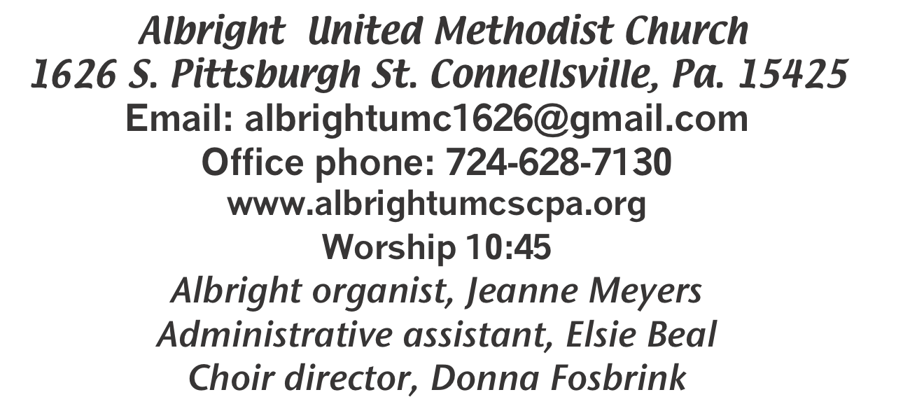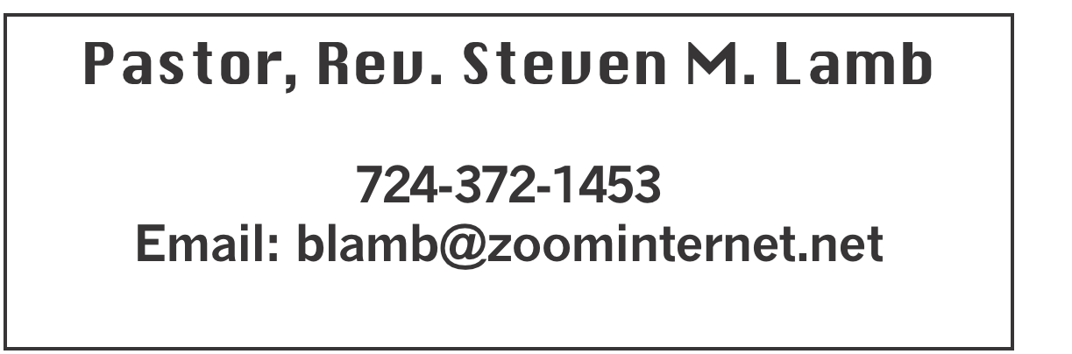

**\*\*\*\*\*\*\*\*\*\*\*\*\*\*\*\*\*\*\*\*\*\*\*\*\*\*\*\*\*\*\*\*\*\*\*\*\*\*\*\*\*\*\*\*\*\*\*\*\*\*\*\*\*\*\***

**December 29, 2024 Liturgist, Ed Jacobs 10:45a.m.**

**First Sunday after Christmas**

**\*\*\*\*\*\*\*\*\*\*\*\*\*\*\*\*\*\*\*\*\*\*\*\*\*\*\*\*\*\*\*\*\*\*\*\*\*\*\*\*\*\*\*\*\*\*\*\*\*\*\*\*\*\*\***

**WELCOME AND ANNOUNCEMENTS**

**PRELUDE “Beautiful Christmas Star” Sturgis**

**BRINGING FORTH THE LIGHT**

**\*OPENING HYMN “Sing We Now of Christmas” 237**

**\*CALL TO WORSHIP**

**Leader: Praise the Lord!**

People: O give thanks to the Lord, for he is good; for his

steadfast love endures forever!

**Leader: Who can utter the mighty doings of the Lord or**

**show forth all his praise?**

***All: Blessed are they who observe justice, who do righteousness at all times!***

**\*OPENING PRAYER**

**Gracious and loving God, as we prepare to begin a new year, help us to discern what it is that moves us. Open our eyes to see the needs of our community, open our ears to hear your call, and open our hearts to be filled by the Holy Spirit. Grant us the courage to use the gifts and talents you have blessed us with to do the work you have called us to. Build this community of faith, strengthening our bonds with one another and with you. Help us to support and encourage one another in our ministry. May all that we do praise you and be to your glory. Amen.**

**\*GLORIA PATRI 70**

**GOSPEL READING Luke 2:41-52**

**The word of God for the people of God. Thanks be to God.**

**CHILDREN’S MOMENT & Coin Offering**

**PASSING THE PEACE**

**OFFERING**

**OFFERTORY “No Room” Peterson**

**\*DOXOLOGY**

**\*OFFERTORY PRAYER**

**PRAYERS OFFERED IN PRAISE AND PETITION**

**PRAYER HYMN “Infant Holy, Infant Lowly” 229**

**PASTORAL PRAYER**

**SILENT MEDITATION**

**THE LORD’S PRAYER**

**ANTHEM “Do You Hear What I Hear?”**

**EPISTLE READING Colossians 3:12-17**

**The word of God for the people of God. Thanks be to God.**

***Thy Word is a lamp unto my feet and a light unto my path***

**MESSAGE “Put On Your Christian Pants”**

**\*CLOSING HYMN “The First Noel” 245**

**\*BENEDICTION**

WELCOME

***Christ Has Come! May He live in our hearts all year. We welcome everyone who has come to worship with us today. We hope to see you every Sunday.***

**\*POSTLUDE** **PRAYER CONCERNS THIS WEEK**

**Don Heckathorne Ray Knopsnider Thomas Leeder Paul & Myra Holden Baby Thompson**

**Becky Irwin James & Deanna Sherbondy Trey Corvin Paula Snyder Allen Mellinger Chadd Tressler Larry Murray Jack Burke Mark Stash Pat Tinkey**

**Rev. Rob & Lynn Kifer Shannon Mack Bradley Sharp Randy Jacobs Tina Hiltabidel Patty Lint Scott Wagner Paula Shaffer Gary Bungard Justin Teets**

**Rick Miller Randy Fisher John Shaw George Mariotti Mary Swope**

**Lee Mimless Kathy Meyers Sandy Fox**

**Buzz & Barb Stuart Ted Zigler Pat Schroyer Lincoln Dunseth Shirley Metsger**

**Nancy Hough** **Sandy Reich John North Rob Miller Pete Darno**

**Judy Eversdyke James Lynn Jane Barnhart John Shay Wanda Brooks**

**Susan Ramage Daniel Swope Jr. Edward John Robert Stewart Ed Butela George Hinklie** Pastor Steve & Bev  **Rev. Ross Pryor Bishop Sandra Steiner Ball**

Homebound persons:  **Edna Baker, Polly Basinger, Evelyn Curry, Sherrill Goodwin, Chuck Hall, Charlotte Holt, Dolly King, Jimmy Lynn, Shirley Mathias, Stephanie Mattis, Mariloyd McClintock, Ed Miller, Judy Morris, Dorene Provance, Ozella Roy**

Unspoken Requests All Military All churches

Government leaders Those with cancer

Those battling addiction Those on Hospice

Praise for answered prayers Homeless people Travelers

Families of those who take their own life

IF YOU WANT A NAME ON PRAYER LIST, PLEASE USE THE PRAYER CARDS IN THE PEW - give to Acolytes.

**THIS WEEK AT ALBRIGHT**

**TODAY: Covered dish potluck after church service. Join us!**

**WEDNESDAY: Bible study 6:30**

**THURSDAY: Choir practice 7:00**

Elsie on vacation Dec. 24-Jan.2. Office closed, will reopen Jan.7

**2025 OFFERING ENVELOPES**

Are out near the bulletins. Small pack is for those who give once a month. Larger packs are for those who give every week.

***POTLUCK COVERED DISH***

***TODAY is our 5th Sunday potluck covered dish lunch after church. Join us for the fellowship even if you didn’t bring a dish.***

FRIENDS OF ALBRIGHT FUND

There are envelopes out near bulletins for the “Friends of Albright Fund” donations. This fund is available to help memebers or friends when they have a need.

LIGHT BULBS AVAILABLE

***We have 4 ft. flourescent bulbs & curly bulbs available. If you want any of them please see Fred. We only ask a***

***donation of your choice for them.***

January Happenings

**Sat., Jan. 11: Soup & Sub sale 10-1.**

**Thurs., Jan. 16: Pasta meal 4-6 at Otterbein**

**Tues., Jan. 21: Church council meeting 7:00**

**Tues., Jan. 21: News deadline for Feb/March newsletter**

**Tues., Jan. 28: Blue Plate special 11:00-1:00**

**Every Thursday at 7:00 Choir practice**

February Happenings

**Fri., Feb. 7 & Sat., Feb. 8 Sub sale $12 each @ 10:00**

**Sat., Feb. 8: Soup sale 10-1**

**Sun., Feb. 9: Super Bowl Sunday - Offering for Food**

**Pantry**

**Thurs., Feb. 20: Pasta meal 4-6 at Otterbein**

**Tues., Feb. 25: Blue Plate Special 11:00-1:00**

**Every Thursday at 7:00 choir practice**

OUR STEWARDSHIP - December 22

**Weekly need for budget ........................................... $ 2,214.00**

**Sunday offering ............................................................... $**

**(Includes Coin offering $**

**Sunday morning worship attendance .....................................**

General Fund balance as of Dec. 1...... Minus - $23,419.35

Monthly need is $10, 506.38

OCTOBER income for the month $8,051.00

NOVEMBER income for the month $8,013.00

WE NEED YOUR HELP & SUPPORT!

**GREETING YOU TODAY: Lynne Corvin**

**Jan. 5: Priscilla “Pinky” Smiley**

**LITURGIST: Ed Jacobs**

**Jan. 5: Scott Murray**

**ACOLYTES TODAY: Kadey & Aubree Shaffer**

**Jan. 5: Thelma Swope & Estella Gallagher**

**JUNIOR CHURCH TODAY: Mandy Lynn & Shelley Mattis**

**Jan. 5: Kathy Hixson & Linda Burnworth**

**USHERS: Volunteers**

**Jan. 5: Jackie Bartholomai, Sherry Grote, Jeremy Gray, Ed Jacobs**

**COUNTERS: December: Larry & Bonnie Bloom**

**January: Sandy Russell & Rick Tressler**

SOUP & SUB SALE

SOUP: Saturday, January 11 at 10:00-1:00. $9 quart; $7 pint. Eat in for a donation of your choice. There is a sheet out in back of sanctuary for you to let us know if you will bring soup. Please sign up. Thank you.

SUBS: 12” Subs $12. We need paid orders in TODAY. Use order forms out near bulletins.

THANK YOU

Thank you very much to the church for the Christmas gift. Thanks also to all those who gave me cards for my birthday and for Christmas. I am very blessed to be working in such a loving church. Christian love to you all. Elsie