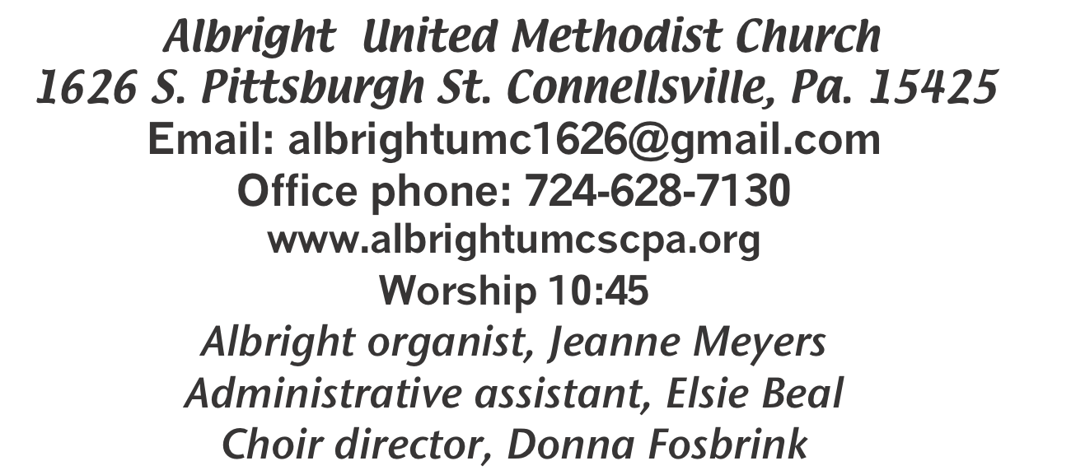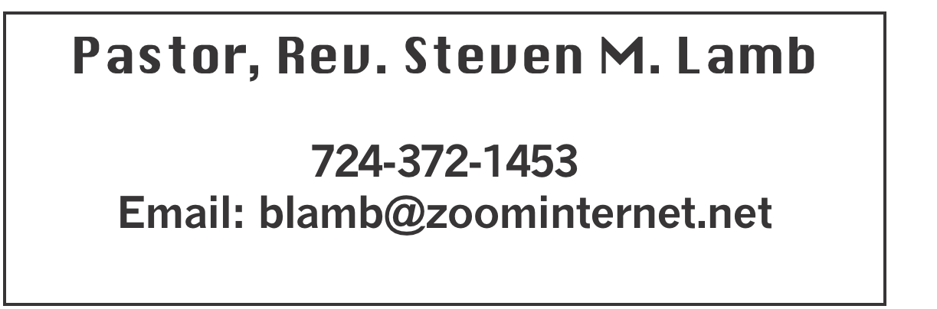

**\\**

**\*\*\*\*\*\*\*\*\*\*\*\*\*\*\*\*\*\*\*\*\*\*\*\*\*\*\*\*\*\*\*\*\*\*\*\*\*\*\*\*\*\*\*\*\*\*\*\*\*\*\*\*\*\*\***

**November 24, 2024 Liturgist, Shelley Mattis 10:45a.m.**

**\*\*\*\*\*\*\*\*\*\*\*\*\*\*\*\*\*\*\*\*\*\*\*\*\*\*\*\*\*\*\*\*\*\*\*\*\*\*\*\*\*\*\*\*\*\*\*\*\*\*\*\*\*\*\*\***

**WELCOME AND ANNOUNCEMENTS**

**PRELUDE “Thanks To Him” Croft**

**BRINGING FORTH THE LIGHT**

**\*OPENING HYMN “Lead on O King Eternal” 580**

**\*CALL TO WORSHIP**

**Leader: The head that once was crowned with thorns**

People: Is crowned with glory now;

**Leader: For life and health his cross was borne;**

People: To him our lives we vow.

**Leader: The highest place that heaven affords**

People: Is his by sovereign right.

**Leader: Yet here for us the Lord of lords**

People: Is pleased to grant his light.

**\*OPENING PRAYER**

**Jesus, what was it like to walk with you when you were here on Earth? Would we have believed in you if we had seen you and heard your voice? We are so grateful for your Word, that tells us the stories of your life, death and resurrection. We are challenged by your words and motivated by your call to love the least of these. Move us away from our selfishness and toward the selfless giving that encompassed all that you were about. Let us never become complacent in our salvation or wary of giving our lives fully to you. You have given all for us, and we give all back to you. Thank you so much, Jesus. We love you. Amen**

**\*GLORIA PATRI 70**

**OLD TESTAMENT READING 2 Samuel 23:1-7**

**The word of God for the people of God. Thanks be to God.**

**CHILDREN’S MOMENT & Coin Offering**

**PASSING THE PEACE**

**OFFERING**

**OFFERTORY “Thak You, Jesus” Hallett**

**\*DOXOLOGY**

**\*OFFERTORY PRAYER**

**PRAYERS OFFERED IN PRAISE AND PETITION**

**PRAYER HYMN“I Want to Walk as a Child of the Light” 206**

**PASTORAL PRAYER**

**SILENT MEDITATION**

**THE LORD’S PRAYER**

**ANTHEM “I Have Seen Jesus In You”**

**EPISTLE READING Revelation 1:4b-8**

**The word of God for the people of God. Thanks be to God.**

***Thy Word is a lamp unto my feet and a light unto my path***

**MESSAGE “Intro”**

**\*CLOSING HYMN “He Is Lord” 177 (2x)**

**\*BENEDICTION**

**\*POSTLUDE**

**\*\*\*\*\*\*\*\*\*\*\*\*\*\*\*\*\*\*\*\*\*\*\*\*\*\*\*\*\*\*\*\*\*\*\*\*\*\*\*\*\*\*\*\*\*\*\*\*\***

WELCOME

***The Lord is in the holy temple; let all the earth keep silence before him! Welcome to all who have come to praise Almighty God. May you be enriched by this worship service.***

**PRAYER CONCERNS THIS WEEK**

**Don Heckathorne Ray Knopsnider Thomas Leeder**

**Paul & Myra Holden Baby Thompson Becky Irwin**

**James & Deanna Sherbondy Trey Corvin Paula Snyder**

**Allen Mellinger Chadd Tressler Mary Swope**

**Jeffrey Sarnelli Larry Murray Pat Tinkey**

**Bobby Kozel Bradley Sharp Shannon Mack**

**Rev. Rob & Lynn Kifer Randy Jacobs Patty Lint**

**Tina Hiltabidel Scott Wagner Paula Shaffer**

**Randy Fisher George Mariotti Lee Mimless**

**Kathy Meyers Sandy Fox Pat Schroyer**

**Buzz & Barb Stuart Ted Zigler Lincoln Dunseth**

**Shirley Metsger** **Sandy Reich John North**

**Rob Miller Pete Darno Judy Eversdyke**

**James Lynn Jane Barnhart Todd Porter**

**Linda Burnworth Daniel Swope Jr. Joyce Camp**

**Sandy Russell Kelly Guidi Bill Dean**

**Georgia - birth of a girl Nancy Hough** Pastor Steve & Bev  **Rev. Ross Pryor Bishop Sandra Steiner Ball**

Homebound persons: **Edna Baker, Polly Basinger, Evelyn Curry, Sherrill Goodwin, Chuck Hall, Dolly King, Jimmy Lynn, Shirley Mathias, Stephanie Mattis, Mariloyd McClintock, Ed Miller, Judy Morris, Ozella Roy**

Unspoken Requests All Military All churches

Government leaders Folks with cancer Those traveling

Those battling addiction Folks on Hospice Homeless people

Praise for answered prayers Peace around the World

Families of those who take their own life

**THIS WEEK AT ALBRIGHT**

**WEDNESDAY: Thanksgiving Eve worship 7:00 at Albright**

**THURSDAY: Thanksgiving Day - OFFICE CLOSED**

**SATURDAY: Hanging of the Greens program 6:00 followed**

**by fellowship & Goofy gift exchange.**

**NO BLUE PLATE SPECIAL THIS MONTH**

OFFICE HOURS**: Tuesday, Wednesday, Thursday 10:00-3:00**

NOTE OF THANKS

***Thank you very much to the Jacobs family for the wonderful Thanksgiving dinner for Saturday Morning Special group.***

OUR STEWARDSHIP - November 17

**Weekly need for budget ........................................... $ 2,214.00**

**Sunday offering ............................................................... $ 1,704.00**

**(Includes Coin offering $38.00 )**

**Sunday morning worship attendance ..................................... 63**

General Fund balance as of Nov. 1...... Minus - $18,831.39

Monthly need is $10, 506.38

SEPTEMBER income for the month $9,840.65

OCTOBER income for the month $8,051.00

WE NEED YOUR HELP & SUPPORT!

**GREETING YOU TODAY: Jackie Kimmel**

**December 1: Kay Jacobs**

**LITURGIST: December 1: Nancy Mimless**

**December 8: Linda Burnworth**

**ACOLYTES TODAY: Beau Wagner & Andrew Lynn**

**Dec. 1: Thelma Swope & Estella Gallagher**

**JUNIOR CHURCH TODAY: David & Shelley Mattis**

**December 1: Kathy Hixson & Linda Burnworth**

**USHERS: Jeremy Gray, Scott Murray, Ed Jacobs, Larry Bloom**

**Dec. 1:Jackie Bartholomai, Sherry Grote, Jeremy Gray, Ed Jacobs**

**COUNTERS: November: Ed Jacobs & Nancy Mimless**

**December: Larry & Bonnie Bloom**

November Happenings

**27th: Thanksgiving Eve Service 7p.m. at Albright**

30th: Hanging of the Greens Christmas Cantata with a play;

Everyone is welcome to celebrate the start of the Advent Season

with our annual Hanging of the Greens. This year we will have a

cantata along with a play reminding us of the meaning of the

season. We will end the evening with our goofy gift exchange &

light refreshments.

December Happenings:

**10th: U.Women in Faith 6:00 - meal and program**

**14th: Annual Cookie Walk from 9-1 where you can purchase a variety of homemade cookies.**

**19th: Otterbein pasta dinner 4-6**

**21st: Saturday Morning Special Christmas Party from 11-1.**

21st: Blue Christmas Service at 7PM at Albright **remembering & celebrating the lives of those we lost and acknowledging the grief we feel in this season.**

24th: Christmas Eve Candlelight **service 7:00 at Otterbein**

Elsie on vacation Dec. 24-Jan.2. Office closed, will reopen Jan.7

THANKSGIVING EVE WORSHIP

**Wednesday, November 27 at 7:00 at Albright.**

COOKIE WALK

**Bev needs to know if you will donate cookies for the Cookie Walk/Sale on Dec. 14 at 9-1. Please sign up on the sheet in the back of the sanctuary by Dec. 1. You may bring them to the church Dec. 12 & 13. Thank you.**

POINSETTIAS

**We will be taking orders for poinsettias from Angie’s Flower Garden. They are available in Red, White, Pink, Red Glitter and are $11.50 for 6” pots. We need paid orders in by Dec. 8. Please use the form in the bulletin to place orders. Thank you.**

**UNITED WOMEN IN FAITH**

**We will meet Tuesday, December 10 at 6:00 for a meal and a program. The program will be Jeanne Meyers & Sharon Grimm. All women of the church are invited to attend.**

**Connellsville West Co-Op church conference**

***December 2nd at Albright UMC. The Co Op leadership will meet at 6:30 in the church basement. A charge Conference will follow at 7:30 in the sanctuary.***

Blue Christmas

**December 21st @ 7:00 p.m. at Albrigh**t

Christmas Eve Service

December 24 at Otterbein 7:00p.m.

LIGHT BULBS AVAILABLE

***We have 4 ft. flourescent bulbs & curly bulbs available. If you want any of them please see Fred. We only ask a donation of your choice for them.***

**POINSETTIAS**

**We are taking orders for poinsettias for Christmas Eve.**

**They are $11.50 each and are available in Red, Pink, White & Red Glitter and are 6” pots wrapped in foil. We are getting them from Angie’s Flower Garden & Greenhouse on Springfield Pike. We need paid orders in to the office by December 8.**

**Please use the form below to put with your money and place in offering plate or drop off at the office during**

**business hours.**

***No orders accepted after December 8***

----------------------------------------------------------------------

**POINSETTIA ORDER FORM**

**Order by Dec. 8**

**_____ Red _____ White _____ Pink _____Red glitter**

**(How many) $11.50 each**

**In Loving Memory Of: In Loving Honor Of:**

**(Please circle one)**

**_______________________________________________**

**_______________________________________________**

**Given By: _____________________________________**

**______________________________________________**

**Amount enclosed $__________________**

jk