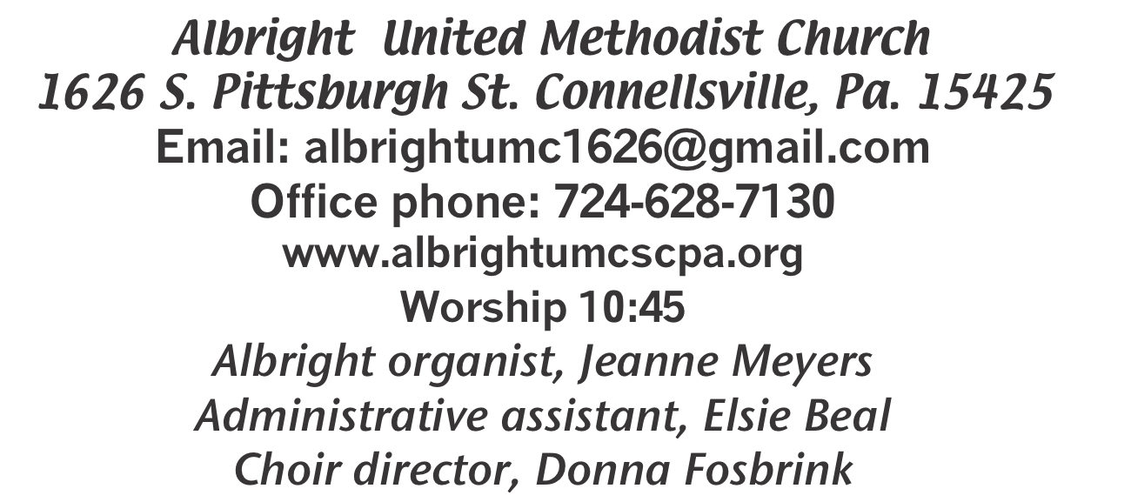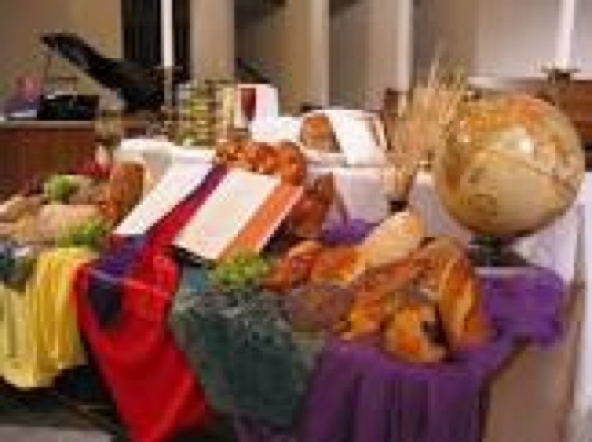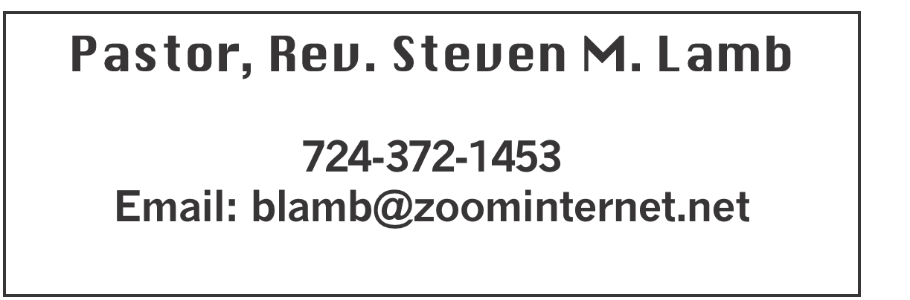

**\*\*\*\*\*\*\*\*\*\*\*\*\*\*\*\*\*\*\*\*\*\*\*\*\*\*\*\*\*\*\*\*\*\*\*\*\*\*\*\*\*\*\*\*\*\*\*\*\*\*\*\*\*\***

**October 6, 2024 Liturgist, Eve Shupe 10:45a.m.**

**World Communion Sunday**

**\*\*\*\*\*\*\*\*\*\*\*\*\*\*\*\*\*\*\*\*\*\*\*\*\*\*\*\*\*\*\*\*\*\*\*\*\*\*\*\*\*\*\*\*\*\*\*\*\*\*\*\*\*\*\*\***

**WELCOME AND ANNOUNCEMENTS**

**PRELUDE “There Is A Fountain” Mason**

**BRINGING FORTH THE LIGHT**

**\*OPENING HYMN “Surely the Presence of the Lord” 328**

**\*CALL TO WORSHIP**

**One: All around the world,**

***All: People rise to greet the morning and sing praise to***

***the Creator.***

**One: All over the earth,**

***All: People hold hands around a table and offer thanks.***

**One: All around the globe,**

***All: Some cry for food, some are filled with laughter, all***

***search for truth.***

**One: All around the world,**

***All: Hearts hear a sacred melody and yearn for peace.***

**One: Throughout this day, across many lands,**

***All: Sisters and brothers touch the bread of life and***

***drink the cup of joy.***

**One: All around the world,**

***All: People sing, and we join the unending chorus of praise***

**\*OPENING PRAYER**

**Compassionate God, open our eyes to the miracles around us. Help us see your gracious provisions in the time of harvest, your refreshing care in the changing seasons. Help us see in the breaking of bread your great love for us. Help us know in our lifting of the cup your tender forgiveness. Open our eyes to see that all are welcome at your table, for your love reconciles differences and your mercy celebrates diversity. In songs and prayers of this day and in the simple gifts of bread and cup, may we catch a glimpse of heaven. Amen.**

**\*GLORIA PATRI 70**

**OLD TESTAMENT READING Job 1:1; 2:1-10**

**The word of God for the people of God. Thanks be to God.**

**ANTHEM Communion Song**

**SERVICE OF HOLY COMMUNION**

**THE LORD’S PRAYER**

**CHILDREN’S MOMENT & Coin offering**

**PASSING THE PEACE**

**OFFERING**

**OFFERTORY “Sheltered in the Arms of God”**

**\*DOXOLOGY Rambo & Davis**

**\*OFFERTORY PRAYER**

**PRAYERS OFFERED IN PRAISE AND PETITION**

**PRAYER HYMN “This Is My Father’s World” 144**

**PASTORAL PRAYER**

**SILENT MEDITATION**

**EPISTLE READING Hebrews 1:1-4; 2:5-12**

**The word of God for the people of God. Thanks be to God.**

***Thy Word is a lamp unto my feet and a light unto my path***

**MESSAGE “Christ Who Names Us”**

**\*CLOSING HYMN “Spirit Song” 347**

**\*BENEDICTION**

**\*POSTLUDE**

**\*\*\*\*\*\*\*\*\*\*\*\*\*\*\*\*\*\*\*\*\*\*\*\*\*\*\*\*\*\*\*\*\*\*\*\*\*\*\*\*\*\*\*\*\*\*\*\*\*\***

**WELCOME**

***We welcome everyone who has come to join us for this World Communion Sunday. We pray you are blessed as we receive communion with other christians around the world.***

**PRAYER CONCERNS THIS WEEK**

**Don Heckathorne Ray Knopsnider Thomas Leeder Paul & Myra Holden Baby Thompson Becky Irwin James & Deanna Sherbondy Trey Corvin Paula Snyder Allen Mellinger Chadd Tressler Mary Swope Jeffrey Sarnelli Emma Jobbs Paul Martin Margaret Shultz Larry Murray Jack Burke Pat Tinkey Bobby Kozel Kenny Urbach Salem Skukar Shannon Mack Bradley Sharp Randy Jacobs**

**Carol Daniels Tina Hiltabidel Scott Wagner Emryn Swaney Judy Strickler**

**Donna Mills Paula Shaffer Patty Lint Gary Bungard Taran Miller Karen Halfhill Shannon Halfhill Justin Teets Rick Miller Bruce Fosbrink**

**Randy Fisher John Shaw George Mariotti Eddie John Buddy Richter**

**Mary Swope Lee Mimless Kathy Meyers Buzz & Barb Stuart Sue Billeaudeau**

**Sandy Fox Ted Zigler Pat Schroyer Lincoln Dunseth Shirley Metsger** **Sandy Reich John North Nolan Smolka Rev. Rob & Lynn Kifer Hurricane victims**

**Sis Groh’s family** Pastor Steve & Bev  **Rev. Ross Pryor Bishop Sandra Steiner Ball**

Homebound persons:  **Edna Baker, Polly Basinger, Evelyn Curry, Sherrill Goodwin, Chuck Hall, Charlotte Holt, Dolly King, Jimmy Lynn, Shirley Mathias, Stephanie Mattis, Mariloyd McClintock, Ed Miller, Judy Morris, Dorene Provance, Ozella Roy**

Unspoken Requests All Military All churches Government leaders Those with cancer

Homeless people Those battling addiction Praise for answered prayers

Families of those who take their own life

If you want a name on prayer list, please use the prayer cards in the pew - give to acolytes.

**THIS WEEK AT ALBRIGHT**

**MONDAY: Co-op leadership & finance com. mtg. 5:30**

**TUESDAY: U.Women in Faith mtg. 6:30 hosting Otterbein**

**ladies for Thank Offering program**

**WEDNESDAY: Bible study 6:30**

**THURSDAY: Choir practice 7:00**

**SATURDAY: OCTOBERFEST 4-7; Craft & Vendor show 2-7**

**Live music 7:00-9:30 p.m. “Winds of Change”**

**SUNDAY: Pastor Appreciation dinner at noon @ Albright**

**WEEKLY BIBLE STUDY**

**Every Wednesday at 6:30 at Albright. Everyone welcome.**

Meeting with DS Pryor at Albright UMC Oct. 7th

Albright leadership (CoOp representatives and members of finance) will meet in the sanctuary at 5:30 prompt to discuss our ability in fiscal support for the cooperative.  **Those who should be present are: Eve Shupe, Sherry Grote, Jeremy Gray, Michelle Reich, Randy Fisher, Jackie Bartholomai, Rick Tressler & Sandy Russell**

***Meeting will last no more than ½ hour.***

UNITED WOMEN IN FAITH

Tues., October 8: We will host the Otterbein ladies at 6:30 for the annual Thank Offering meal & program. All ladies of the church are invited to join us.

**PASTOR APPRECIATION DINNER**

**Sun., Oct. 13 at noon at Albright our annual appreciation day to say “Thank You” to Pastor Steve & Bev for all they do in our churches.**  Please make reservations TODAY.

OPERATION CHRISTMAS CHILD

**We will be doing shoeboxes again this year. You may use the regular shoe boxes or get plastic shoebox size. We need them in by November 17.**

**OCTOBER CALENDAR**

**Mon., 7: Co-op leadership meet with D.S. Prior 5:30**

**Tues., 8: U.Women in Faith 6:30 host Otterbein ladies**

**Tues., 8: U.Women in Faith 6:30 host Otterbein ladies**

**Wed., 9: Bible study 6:30**

**Thurs.,10: Choir practice 7:00**

**Sat., 12: Octoberfest 4-7 & Craft & Vendor show 2-7;**

**Live music “Winds of Change” 7:00-9:30 p.m.**

**Sun., 13: Pastor Appreciation dinner at Albright - noon**

**Wed., 16: Bible study 6:30**

**Thurs., 17: Pasta meal at Otterbein 4-6**

**Choir practice 7:00**

**Sat., 19: Saturday Morning Special halloween party 11:00**

OUR STEWARDSHIP - September 29

**Weekly need for budget ........................................... $ 2,214.00**

**Sunday offering ............................................................... $ 2,430.00**

**(Coin offering $57)**

**Sunday morning worship attendance ..................................... 55**

OFFICE HOURS**: Tuesday, Wednesday, Thursday 10:00-3:00**

General Fund balance as of Oct. 1...... Minus - $18,831.39

Monthly need is $10, 506.38

AUGUST income for the month $ 10,156.00

SEPTEMBER income for the month $9,840.65

WE NEED YOUR HELP & SUPPORT!

**GREETING YOU TODAY: Fred & Sherry Grote**

**October 13: Pamela Lynn**

**LITURGIST: October 13: Bonnie Bloom**

**October 20: Karen Stimmell**

**ACOLYTES TODAY: Piper Marko & Jameson Tony**

**October 13: Andrew Lynn & Beau Wagner**

**JUNIOR CHURCH TODAY: Kathy Hixson & Linda Burnworth**

**Oct. 13: Kelli Armstrong & Nancy Mimless**

**USHERS: Pinky Smiley, Sherry Grote, Jeremy Gray & Ed Jacobs**

**Oct. 13:Larry Bloom, Scott Murray, Sally Fosbrink, Michelle Reich**

**COUNTERS: October: Sherry Grote & Sue Harvey**

**November: Ed Jacobs & Nancy Mimless**

§§§§§§§§§§§§§§§§§§§§§§§§§§§§§§§§§§§§§§§§§§§§§§§§§§§§§§§

OCTOBERFEST &

CRAFT/VENDOR SHOW

SATURDAY, OCTOBER 12

***Octoberfest from 4:00-7:00. We are planning a variety of German foods available to purchase. Pork, sauerkraut, mashed potatoes, dumplings, hot dogs, apple streudel, etc.***

Craft & Vendor Show 2:00-7:00

**OPEN TO THE PUBLIC!!**

**We will have live music at 7:00 with the band “Winds of Change” (John Hammond’s group) 7:00-9:30 p.m**

We invite you to come and have a good time with us.

§§§§§§§§§§§§§§§§§§§§§§§§§§§§§§§§§§§§§§§§§§§§§§§§§§§§