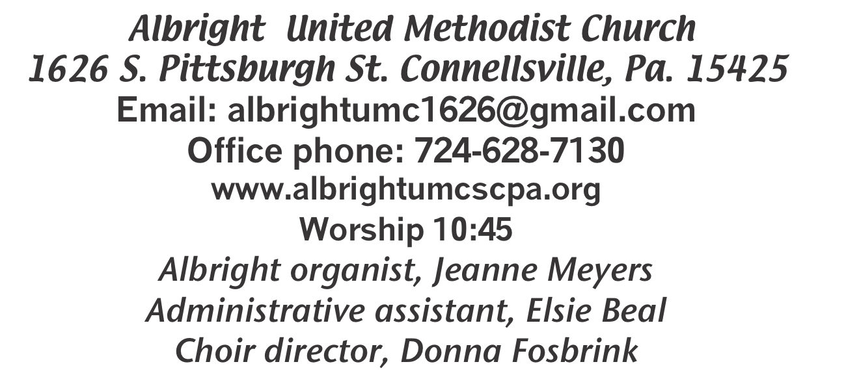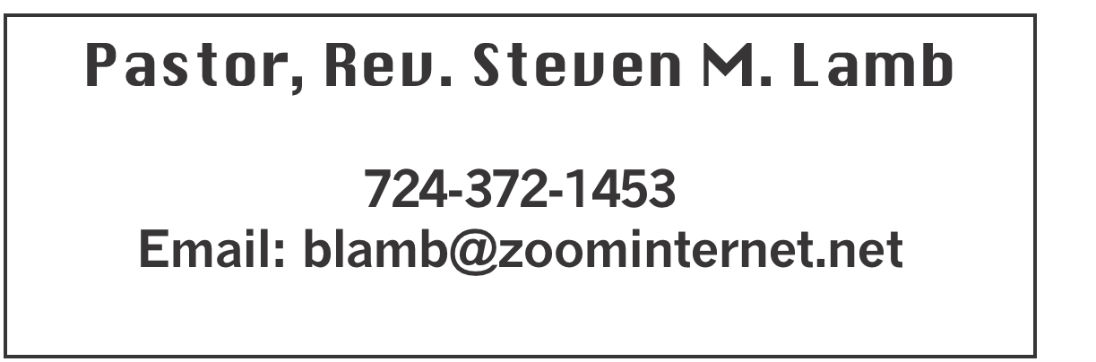

**\*\*\*\*\*\*\*\*\*\*\*\*\*\*\*\*\*\*\*\*\*\*\*\*\*\*\*\*\*\*\*\*\*\*\*\*\*\*\*\*\*\*\*\*\*\*\*\*\*\*\*\*\*\***

**September 8, 2024 Liturgist, Ed Jacobs 10:45a.m.**

**Outdoor Service**

**\*\*\*\*\*\*\*\*\*\*\*\*\*\*\*\*\*\*\*\*\*\*\*\*\*\*\*\*\*\*\*\*\*\*\*\*\*\*\*\*\*\*\*\*\*\*\*\*\*\*\*\*\*\*\*\*\***

**WELCOME AND ANNOUNCEMENTS**

**PRELUDE “Until You’ve Known the Love of God” Goodman**

**\*OPENING HYMN “In The Garden” 314**

**\*CALL TO WORSHIP: An Affirmation of Faith**

**L: I believe in an innovative God,**

**who does not wait for us to find ourselves**

**but comes seeking the lost and calling us into a new way.**

***ALL: I believe in Jesus of Nazareth as God’s crucial initiative,***

***that when he calls us to follow, Christ also gives us the power to become, both in creed and deed, the children of the living God.***

**L: I believe in the Spirit by whom Jesus still comes to us,**

**calling us to follow him into an obedience which is true liberty and to a humble service which is the fruit of holy**

**friendship.**

***ALL: I believe in the church as the fellowship of Christ’s***

***people,called to respect and support one another through***

***joys and tribulations as we travel the road towards the***

***“promised land” of God’s future. Because Christ has called me, in this I truly believe. Amen.***

**\*OPENING PRAYER**

**Lord, you have given us your Word for a light to shine upon our path; grant us so to meditate on that Word, and to follow its teaching, that we may find in it the light that shines more and more until the perfect day; through Jesus Christ our Lord. Amen. *—Saint Jerome, 342-420*.**

**\*GLORIA PATRI 70**

**OLD TESTAMENT READING Psalm 125**

**The word of God for the people of God. Thanks be to God**

**CHILDREN’S MOMENT & Coin offering**

**\*PASSING THE PEACE**

**OFFERING**

**OFFEERTORY Pastor Steve**

**\*DOXOLOGY**

**\*OFFERTORY PRAYER**

**PRAYERS OFFERED IN PRAISE AND PETITION**

**(Please give prayer cards to acolytes)**

**PRAYER HYMN “Here I Am, Lord” 593**

**PASTORAL PRAYER**

**SILENT MEDITATION**

**THE LORD’S PRAYER**

**SPECIAL MUSIC Pastor Steve**

**EPISTLE READING Hebrews 2:10-18**

**The word of God for the people of God. Thanks be to God.**

***Thy Word is a lamp unto my feet and a light unto my path***

**MESSAGE “In the Public Domain”**

**\*CLOSING HYMN “Lift High the Cross” 159**

**\*BENEDICTION**

**\*POSTLUDE**

**\*\*\*\*\*\*\*\*\*\*\*\*\*\*\*\*\*\*\*\*\*\*\*\*\*\*\*\*\*\*\*\*\*\*\*\*\*\*\*\*\*\*\*\*\*\*\*\*\***

WELCOME

***We welcome everyone who has come to worship with us on this special Sunday in the outdoors. We pray you will be blessed and will be a blessing to all you meet this week.***

**PRAYER CONCERNS THIS WEEK**

**Don Heckathorne Ray Knopsnider Thomas Leeder Paul & Myra Holden Baby Thompson Becky Irwin James & Deanna Sherbondy Trey Corvin Paula Snyder Allen Mellinger Chadd Tressler Mary Swope Jeffrey Sarnelli Emma Jobbs Paul Martin Margaret Shultz Larry Murray Jack Burke Pat Tinkey Bobby Kozel**

**Rev. Rob Kifer Kenny Urbach Salem Skukar Shannon Mack Bradley Sharp**

**Randy Jacobs Carol Daniels Denny Dunn Kayla Hann Toni Jones**

**Will Johnson Tina Hiltabidel Scott Wagner Emryn Swaney Judy Strickler**

**Donna Mills Paula Shaffer Patty Lint Gary Bungard Taran Miller Karen Halfhill Shannon Halfhill Justin Teets Rick Miller Bruce Fosbrink**

**Randy Fisher John Shaw George Mariotti Eddie John Buddy Richter**

**Lee Mimless Shirley Kozel Buzz & Barb Stuart Kathy Meyers Sue Billeaudeau**

**Sandy Fox Ted Zigler David Bradley’s family** Pastor Steve & Bev  **Rev. Ross Pryor**

**Bishop Cynthia Moore-Koikoi**

Homebound persons:  **Edna Baker, Polly Basinger, Evelyn Curry, Sherrill Goodwin, Chuck Hall, Charlotte Holt,**

**Dolly King, Jimmy Lynn, Shirley Mathias, Stephanie**

**Mattis, Mariloyd McClintock, Ed Miller, Judy Morris, Dorene Provance, Ozella Roy**

Unspoken Requests All Military All churches

Government leaders Those with cancer

Those battling addiction Praise for answered prayers

Families of those who take their own life

If you want a name on prayer list, please use the prayer cards in the pew - give to acolytes.

**THIS WEEK AT ALBRIGHT**

**TODAY: Orders for subs due**

**TUESDAY: United Women in Faith meeting 7:00**

**WEDNESDAY: Bible study 6:30**

**THURSDAY: Choir practice 7:00**

**FRIDAY & SATURDAY: Sub sale 10-1 each day**

OFFICE HOURS**: Tuesday, Wednesday, Thursday 10:00-3:00**

UNITED WOMEN IN FAITH

**Will meet Tuesday, September 10 at 7:00. All women of the church are invited to join us.**

**WEEKLY BIBLE STUDY**

**Wednesdays beginning Sept. 11 at 6:30. Everyone welcome.**

PPSRC COMMITTEE

**Will meet Monday, September 16 at 6:30. Members are: Sandy Russell, chair, Jeremy Gray, Eve Shupe, Vicky Adey, Linda Burnworth, Rick Tressler.**

CHURCH COUNCIL

**Will meet Tuesday, September 17 at 7:00.**

OCT/NOV NEWSLETTER

**Wednesday, September 18: News deadline.**

PASTA MEAL

**Thurs., Sept. 19 at Otterbein 4-6 p.m. Free with donations**

**accepted. $5 for take out.**

PREPARING FOR HANGING OF GREENS

We will be working on Christmas decorations on Tuesdays at 10:00 and Thursdays at 5:00. If you want to help, please come.

§§§§§§§§§§§§§§§§§§§§§§§§§§§§§§§§§§§§§§§§§§§§§§§§§§§§§§§

OCTOBERFEST & CRAFT/VENDOR SHOW

SATURDAY, OCTOBER 12

***Octoberfest from 4:00-7:00. We are planning a variety of German foods available to purchase. Pork, sauerkraut, mashed potatoes, dumplings, hot dogs, apple streudel, etc.***

**We will have live music at 7:00 with the band “Winds of Change” (John Hammond’s group) 7:00-9:30 p.m**

Crafters & Vendors will be setting up 2:00-7:00 that day. If you would be interested in setting up, please contact Beverly Lamb at 724-372-1456 or call the church office 724-628-7130. Cost is $25 for first table and $15 for second table. **OPEN TO THE PUBLIC!!**

We invite you to come and have a good time with us.

§§§§§§§§§§§§§§§§§§§§§§§§§§§§§§§§§§§§§§§§§§§§§§§§§§§§

OUR STEWARDSHIP - September 1

**Weekly need for budget ........................................... $ 2,214.00**

**Sunday offering ............................................................... $ 2,608.00**

**Sunday morning worship attendance ..................................... 58**

General Fund balance as of Sept. 1...... Minus - $17,416.95

Monthly need is $10, 506.38

JULY income for the month was $ 8,079.07

AUGUST income for the month $ 10,156.00

WE NEED YOUR HELP & SUPPORT!

**GREETING YOU TODAY: Priscilla Smiley**

**September 15: Karen Stimmell**

**LITURGIST: September 15: Jessica Bortz**

**September 22: Scott Murray**

**ACOLYTES TODAY: NO acolytes today**

**September 15: Kayton & Keelan Callahan**

**JUNIOR CHURCH TODAY: Kelli Armstrong & Nancy Mimless**

**September 15: Bonnie & Larry Bloom**

**USHERS:Larry Bloom, Scott Murray, Sally Fosbrink, Michelle Reich**

**Sept. 15: Jay & Judy Whipkey, Linda Burnworth, Pinky Smiley**

**COUNTERS: September: Jay Whipkey & Karen Stimmell**

**October: Sherry Grote & Sue Harvey**

SEPTEMBER CALENDAR

Tues., Sept. 10 @ 7:00 - United Women in Faith mtg

Wed., Sept. 11 @ 6:30 - Weekly Bible study begins

Thurs., Sept. 12 @ 7:00 - Choir practice

Fri., Sept 13 & Sat., Sept 14 @ 10-1 Sub sale

Sat., Sept. 14 @ 10:00 - Basket class

Tues., Sept. 17 @ 7:00 - Church council meeting

Wed., Sept. 18 - Oct/Nov newsletter news deadline

Thurs., Sept. 19 @ 4-6 - Otterbein Pasta meal

Tues., Sept. 24 @ 11-1 - Blue plate special luncheon

Sun., Sept. 29 @ 10:45 Anniversary Sunday followed by potluck

PASTOR APPRECIATION DAY

***Sun., Oct. 13 our annual appreciation day to say “Thank You” to Pastor Steve & Bev for all they do in our churches. The meal will follow morning worship at Albright. It will be catered by Hartsek. Cost $15 each. Menu: Stuffed chicken breast, Ham, mashed potatoes & gravy, green beans,penne pasta with red sauce, salad & rolls. Cake provided by Otterbein church.***