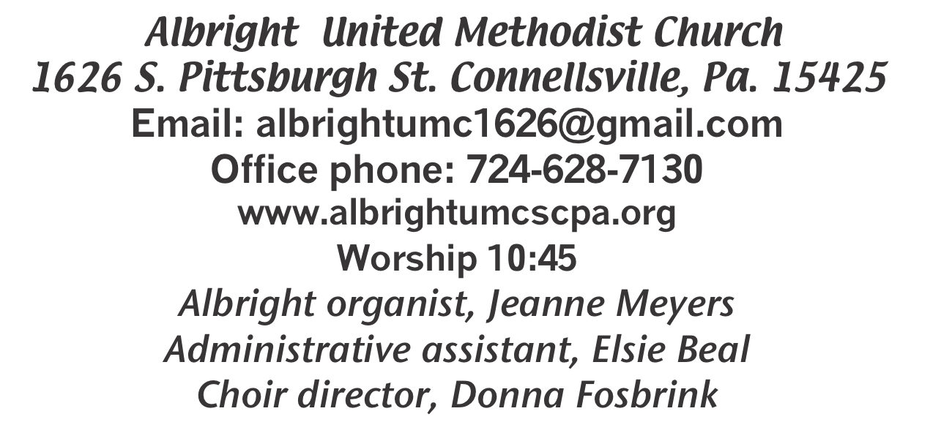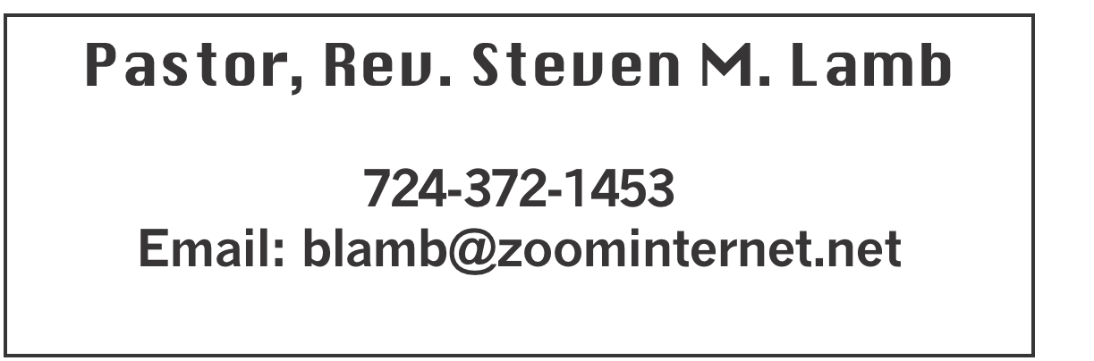

**\*\*\*\*\*\*\*\*\*\*\*\*\*\*\*\*\*\*\*\*\*\*\*\*\*\*\*\*\*\*\*\*\*\*\*\*\*\*\*\*\*\*\*\*\*\*\*\*\*\*\*\*\*\***

**September 22, 2024 Liturgist, Scott Murray 10:45a.m.**

**\*\*\*\*\*\*\*\*\*\*\*\*\*\*\*\*\*\*\*\*\*\*\*\*\*\*\*\*\*\*\*\*\*\*\*\*\*\*\*\*\*\*\*\*\*\*\*\*\*\*\*\*\*\*\*\***

**WELCOME AND ANNOUNCEMENTS**

**PRELUDE “He Set Me Free” Brunley**

**BRINGING FORTH THE LIGHT**

**\*OPENING HYMN “Jesus Loves Me This I Know” 191**

**\*CALL TO WORSHIP**

**L: Come let us worship the Lord.**

P: God longs to give us the desires of our heart.

**L: Let us bow down amid our preconceived, irreverent**

**ideals.**

P: The law of the LORD is perfect, reviving the soul.

**L: For God seeks to enter into covenant with the children**

**of all creation.**

P: Fill us, O Lord, with a sense of respect and awe, as you

rouse yourself from your holy dwelling place to touch

each of us ... just as we are, where we are.

***ALL: Praise your holy name***

**\*OPENING PRAYER**

**How easy it is at times to accept worldly wisdom as divine. Make of us a people flowing within the stream of your Spirit’s truth and mercy. Help us to irrigate with peace a community full of righteousness and love where we treat our brothers and sisters with dignity and honor. Bring us into the fullness of life by the Spirit of the living God that goes before us. Amen.**

**\*GLORIA PATRI 70**

**EPISTLE READING James 3:13-4:3, 7**

**The word of God for the people of God. Thanks be to God.**

**CHILDREN’S MOMENT & Coin Offering**

**PASSING THE PEACE**

**OFFERING**

**OFFERTORY “It Is No Secret” Hamblen**

**\*DOXOLOGY**

**\*OFFERTORY PRAYER**

**PRAYERS OFFERED IN PRAISE AND PETITION**

**PRAYER HYMN “Be Thou My Vision” 451**

**PASTORAL PRAYER**

**SILENT MEDITATION**

**THE LORD’S PRAYER**

**ANTHEM “If We Ever/Down By the Riverside”**

**OLD TESTAMENT READING Psalm 1**

**The word of God for the people of God. Thanks be to God.**

***Thy Word is a lamp unto my feet and a light unto my path***

**MESSAGE “The Roots”**

**\*CLOSING HYMN “Near to the Heart of God” 472**

**\*BENEDICTION**

**\*POSTLUDE**

**\*\*\*\*\*\*\*\*\*\*\*\*\*\*\*\*\*\*\*\*\*\*\*\*\*\*\*\*\*\*\*\*\*\*\*\*\*\*\*\*\*\*\*\*\*\*\*\*\***

WELCOME

***We happily greet each person who has come to worship. May the Spirit of God give encouragement to all as we face the challenges of life.***

**PRAYER CONCERNS THIS WEEK**

**Don Heckathorne Ray Knopsnider Thomas Leeder Paul & Myra Holden**

**Baby Thompson Becky Irwin James & Deanna Sherbondy Trey Corvin**

**Paula Snyder Allen Mellinger Chadd Tressler Mary Swope**

**Jeffrey Sarnelli Emma Jobbs Paul Martin Margaret Shultz**

**Larry Murray Jack Burke Pat Tinkey Bobby Kozel**

**Rev. Rob Kifer Kenny Urbach Salem Skukar Shannon Mack**

**Bradley Sharp Randy Jacobs Carol Daniels Tina Hiltabidel**

**Scott Wagner Emryn Swaney Judy Strickler Donna Mills**

**Paula Shaffer Patty Lint Gary Bungard Taran Miller**

**Karen Halfhill Shannon Halfhill Justin Teets Rick Miller**

**Bruce Fosbrink Randy Fisher John Shaw George Mariotti**

**Eddie John Buddy Richter Mary Swope Lee Mimless**

**Kathy Meyers Buzz & Barb Stuart Sue Billeaudeau Sandy Fox**

**Ted Zigler Pat Schroyer Lincoln Dunseth Shirley Metsger**

**Sandy Reich John North Shirley Kozel’s family** Pastor Steve & Bev

**Rev. Ross Pryor Bishop Sandra Steiner Ball**

Homebound persons: **Edna Baker, Polly Basinger, Evelyn Curry, Sherrill Goodwin, Chuck Hall, Charlotte Holt, Dolly King, Jimmy Lynn, Shirley Mathias, Stephanie**

**Mattis, Mariloyd McClintock, Ed Miller, Judy Morris, Dorene Provance, Ozella Roy**

Unspoken Requests All Military All churches

Government leaders Those with cancer Those traveling

Those battling addiction Those on Hospice Homeless people

Praise for answered prayers

Families of those who take their own life

**THIS WEEK AT ALBRIGHT**

**MONDAY: Nominating committee meeting 7**

**TUESDAY: Blue Plate Special lunch 11-1**

**WEDNESDAY: Bible study 6:30**

**THURSDAY: Choir practice 7:00**

**SUNDAY: Anniversary Sunday & Potluck**

OFFICE HOURS**: Tuesday, Wednesday, Thursday 10:00-3:00**

**WEEKLY BIBLE STUDY**

**Every Wednesday at 6:30 at Albright. Everyone welcome.**

**NOMINATING COMMITTEE MEETING**

**Monday, Sept. 23 at 7:00. Members:Vicky Adey, Shelley Mattis, Karen Stimmell, Pinky Smiley, Jackie Bartholomai, Lynne Corvin, Rick Tressler.**

Meeting with DS Pryor at Albright UMC

October 7th

Albright leadership (CoOp representatives and members of finance) will meet in the sanctuary at 5:30 prompt to discuss our ability in fiscal support for the cooperative.  **Those who should be present are: Eve Shupe, Sherry Grote, Jeremy Gray, Michelle Reich, Randy Fisher, Jackie Bartholomai, Rick Tressler & Sandy Russell**

Meeting will last no more than ½ hour.

§§§§§§§§§§§§§§§§§§§§§§§§§§§§§§§§§§§§§§§§§§§§§§§§§§§§§§§

OCTOBERFEST & CRAFT/VENDOR SHOW

SATURDAY, OCTOBER 12

***Octoberfest from 4:00-7:00. We are planning a variety of German foods available to purchase. Pork, sauerkraut, mashed potatoes, dumplings, hot dogs, apple streudel, etc.***

**We will have live music at 7:00 with the band “Winds of Change” (John Hammond’s group) 7:00-9:30 p.m**

Crafters & Vendors will be setting up 2:00-7:00 that day. If you would be interested in setting up, please contact Beverly Lamb at 724-372-1456 or call the church office 724-628-7130. Cost is $25 for first table and $15 for second table. **OPEN TO THE PUBLIC!!**

We invite you to come and have a good time with us.

§§§§§§§§§§§§§§§§§§§§§§§§§§§§§§§§§§§§§§§§§§§§§§§§§§§§

OPERATION CHRISTMAS CHILD

**We will be doing shoeboxes again this year. You may use the regular shoe boxes or get plastic shoebox size.**

OUR STEWARDSHIP - September 15

**Weekly need for budget ........................................... $ 2,214.00**

**Sunday offering ............................................................... $ 3,187.00**

**Sunday morning worship attendance ..................................... 49**

General Fund balance as of Sept. 1...... Minus - $17,416.95

Monthly need is $10, 506.38

JULY income for the month was $ 8,079.07

AUGUST income for the month $ 10,156.00

WE NEED YOUR HELP & SUPPORT!

**GREETING YOU TODAY: Karen Stimmell**

**September 29: Elsie Beal**

**LITURGIST: September 29: Sherry Grote**

**October 6: Eve Shupe**

**ACOLYTES TODAY: Olivia Lynn & Emmaleigh Kalemba**

**September 29: Aubree & Kadey Shaffer**

**JUNIOR CHURCH TODAY: Need volunteers**

**September 29: Shelley Mattis & Mandy Lynn**

**USHERS: Jeremy Gray, Scott Murray, Ed Jacobs, Larry Bloom**

**Sept. 29: Volunteers**

**COUNTERS: September: Jay Whipkey & Karen Stimmell**

**October: Sherry Grote & Sue Harvey**

SEPTEMBER CALENDAR

Tues., Sept. 24 @ 11-1 - Blue plate special luncheon

Sun., Sept. 29 @ 10:45 Anniversary Sunday followed by potluck

PASTOR APPRECIATION DAY

***Sun., Oct. 13 our annual appreciation day to say “Thank You” to Pastor Steve & Bev for all they do in our churches. The meal will follow morning worship at Albright. It will be catered by Hartsek. Cost $15 each. Menu: Stuffed chicken breast, Ham, mashed potatoes & gravy, green beans,penne pasta with red sauce, salad & rolls. Cake provided by Otterbein church.***

Please make reservations. Put money in an

envelope with how many attending & give to Eve Shupe by October 6.