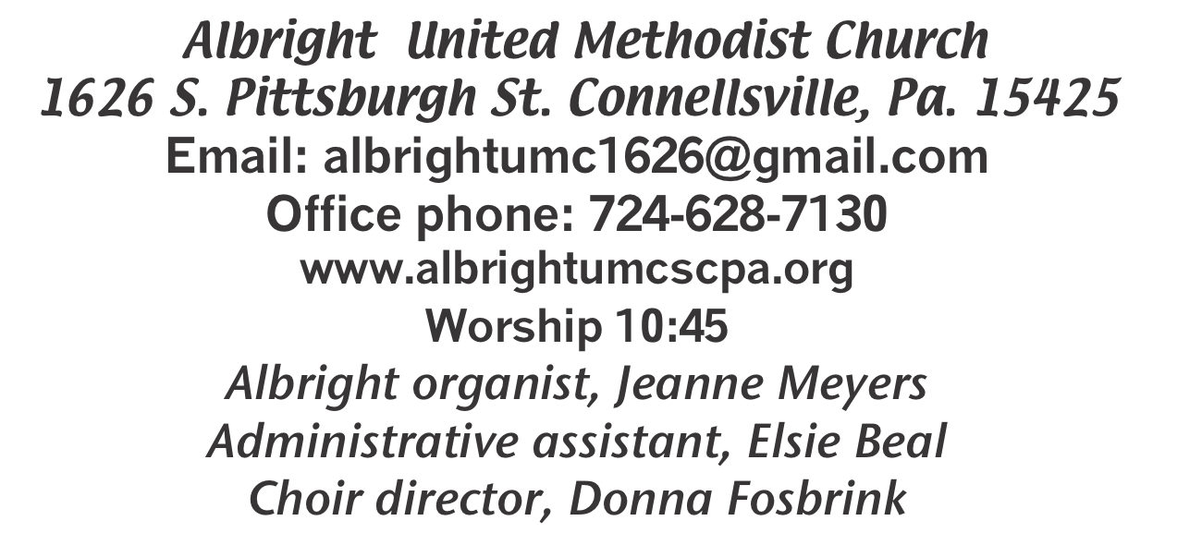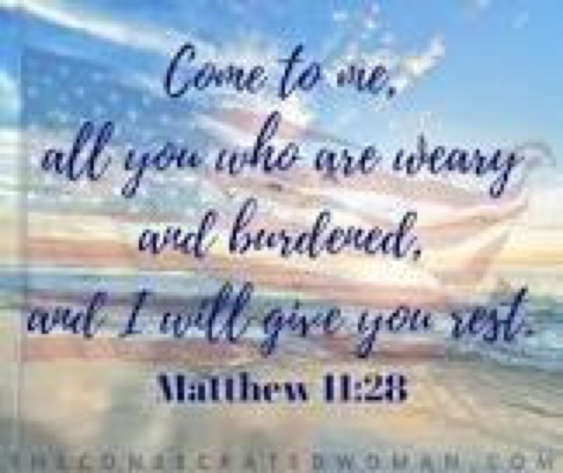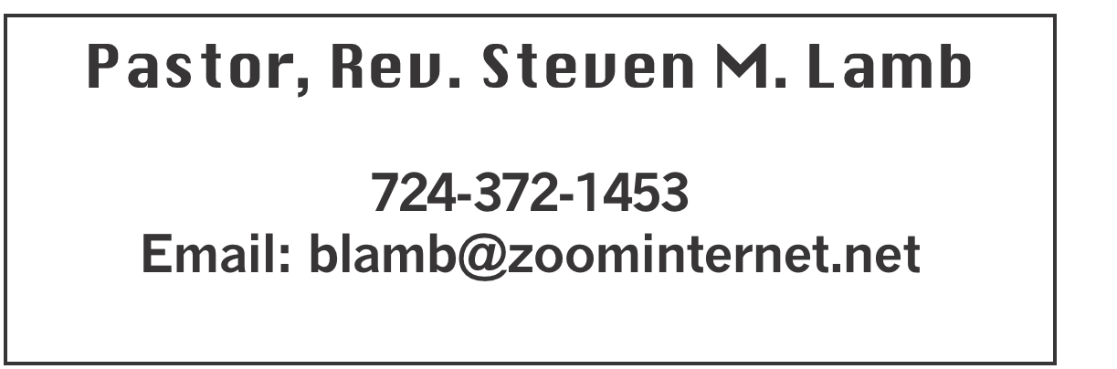

**\*\*\*\*\*\*\*\*\*\*\*\*\*\*\*\*\*\*\*\*\*\*\*\*\*\*\*\*\*\*\*\*\*\*\*\*\*\*\*\*\*\*\*\*\*\*\*\*\*\*\*\*\*\***

**September 1, 2024 Liturgist, Myra Holden 10:45a.m.**

**\*\*\*\*\*\*\*\*\*\*\*\*\*\*\*\*\*\*\*\*\*\*\*\*\*\*\*\*\*\*\*\*\*\*\*\*\*\*\*\*\*\*\*\*\*\*\*\*\*\*\*\*\*\*\*\***

**WELCOME AND ANNOUNCEMENTS**

**PRELUDE “Got Any Rivers?” Eliason**

**BRINGING FORTH THE LIGHT**

**\*OPENING HYMN “My Hope Is Built” 368**

**\*CALL TO WORSHIP**

**L: A gift of a new day,**

***All: Unlived, untried, ready to be opened.***

**L: A new day with surprising miracles;**

**All: With love to be given,**

**L: Kindness to be shared**

**All: And peace to be enjoyed.**

**L: A gift of a new day,**

**All: God’s gift to us.**

**L: Let us receive it with joy**

**All: And live it in expectation**

**\*OPENING PRAYER**

**God, you are the Gardener gently cultivating the soil and seeds of our lives. You give us water and sun and wind and nutrients and life. Thank you for all you give us, for your Spirit that nurtures and sustains us, for growing seasons and especially for the warmth of the sun. May we be nourished into new blossoms of abundant life. May we learn the gifts of gentleness, kindness, compassion and peace. Help us now to always be forgiving and loving. Show us how to turn away from anger and hate. Help us, Lord, to appreciate all that we are — our lives and spirits, our bodies and our thoughts. And always, Lord, grow within us the desire to live and work for peace in our church, in our families, in our neighborhoods, in our nation, and most especially in our world. Amen.**

**\*GLORIA PATRI 70**

**OLD TESTAMENT READING Song of Solomon 2:8-13**

**The word of God for the people of God. Thanks be to God.**

**SPECIAL MUSIC David & Shelley Mattis**

**SERVICE OF HOLY COMMUNION**

**LORD’S PRAYER**

**CHILDREN’S MOMENT & Coin offering**

**PASSING THE PEACE**

**PRAYER REQUESTS**

**(give prayer cards to acolytes)**

**OFFERING**

**OFFERTORY Dave & Shelley Mattis**

**\*DOXOLOGY**

**\*OFFERTORY PRAYER**

**PRAYERS OFFERED IN PRAISE AND PETITION**

**PRAYER HYMN “What Wondrous Love is This” 292**

**PASTORAL PRAYER**

**SILENT MEDITATION**

**EPISTLE READING James 1:17-27**

**The word of God for the people of God. Thanks be to God.**

***Thy Word is a lamp unto my feet and a light unto my path***

**MESSAGE “Had-To”**

**\*CLOSING HYMN “When We All Get to Heaven” 701**

**\***

**BENEDICTION**

**\*POSTLUDE**

**\*\*\*\*\*\*\*\*\*\*\*\*\*\*\*\*\*\*\*\*\*\*\*\*\*\*\*\*\*\*\*\*\*\*\*\*\*\*\*\*\*\*\*\*\*\*\*\*\*\***

**WELCOME**

***On this Labor Day weekend we welcome you to our worship***

***service. Our prayer is that everyone will feel God’s presence and carry that feeling with you always.***

**PRAYER CONCERNS THIS WEEK**

**Don Hckathorne Ray Knopsnider Thomas Leeder Paul & Myra Holden Baby Thompson Becky Irwin James & Deanna Sherbondy Trey Corvin Paula Snyder Susie Mongell Keith Morris Loretta Capo Allen Mellinger Kilee Robinson Chadd Tressler**

**Mary Swope Rich Marto Jeffrey Sarnelli Emma Jobbs Paul Martin Margaret Shultz Donna Fosbrink Madelyn Johnson Larry Murray Jack Burke**

**Pat Tinkey Bobby Kozel Rev. Rob Kifer Kenny Urbach Salem Skukar**

**Shannon Mack Bradley Sharp Randy Jacobs Carol Daniels Denny Dunn**

**Kayla Hann Toni Jones Will Johnson Tina Hiltabidel Zack Martin**

**Scott Wagner Fred Grote Emryn Swaney Judy Strickler Donna Mills**

**Paula Shaffer Patty Lint Gary Bungard Taran Miller John Lypson**

**Karen Halfhill Shannon Halfhill Justin Teets Rick Miller Bruce Fosbrink**

**Randy Fisher John Shaw George Mariotti Eddie John Buddy Richter**

**Lee Mimless** Pastor Steve & Bev  **Rev. Ross Pryor Bishop Cynthia Moore-Koikoi**

Homebound persons: **Polly Basinger, Charlotte Holt, Dolly King, Shirley Mathias, Mariloyd McClintock, Edna Baker, Jimmy Lynn, Ozella Roy, Evelyn Curry, Judy Morris, Chuck Watson, Ed Miller, Dorene Provance, Jean Rahl (now on Hospice), Sherrill Goodwin, Chuck Hall, Stephanie Mattis**

Unspoken Requests All Military All churches

Government leaders Those with cancer

Those battling addiction Praise for answered prayers

Families of those who take their own life

If you want a name on prayer list, please use the prayer cards in the pew - give to acolytes.

**THIS WEEK AT ALBRIGHT**

**MONDAY: LABOR DAY**

**THURSDAY: Women’s Day Apart at Jumonville**

**SATURDAY: Saturday Morning Special 11:00**

OFFICE HOURS**: Tuesday, Wednesday 10:00-3:00**

**(Office Closed Thursday - Elsie at Jumonville)**

SEPTEMBER CALENDAR

Sat., Sept. 7 @ 11:00 - Saturday Morning Special

Sun., Sept. 8 @ 10:45 - Outdoor worship service near the

Gazebo; followed by a covered dish picnic in the

pavilion. Bring a lawn chair for comfort.

Tues., Sept. 10 @ 7:00 - United Women in Faith mtg

Wed., Sept. 11 @ 6:30 - Weekly Bible study begins

Thurs., Sept. 12 @ 7:00 - Choir practices begin

Fri., Sept 13 & Sat., Sept 14 @ 10-1 Sub sale

Sat., Sept. 14 @ 10:00 - Basket class

Tues., Sept. 17 @ 7:00 - Church council meeting

Wed., Sept. 18 - Oct/Nov newsletter news deadline

Thurs., Sept. 19 @ 4-6 - Otterbein Pasta meal

Tues., Sept. 24 @ 11-1 - Blue plate special luncheon

Sun., Sept. 29 @ 10:45 Anniversary Sunday followed by a

potluck covered dish lunch

SATURDAY MORNING SPECIAL

**This ministry for persons with special needs will gather Saturday, September 7 at 11:00. They will have grilled cheese & tomato soup.**

§§§§§§§§§§§§§§§§§§§§§§§§§§§§§§§§§§§§§§§§§§§§§§§§§§§§§§§

OCTOBERFEST &

CRAFT/VENDOR SHOW

SATURDAY, OCTOBER 12

***We will have an Octoberfest from 4:00-7:00. We are planning on having a variety of German foods available. Pork, sauerkraut, mashed potatoes, dumplings, hot dogs, apple streudel, etc. We will have live music at 7:00 with the band “Winds of Change” (John Hammond’s group) 7:00-9:30.***

Crafters & Vendors will be setting up 2:00-7:00 that day. If you would be interested in setting up, please contact Beverly Lamb at 724-372-1456 or call the church office 724-628-7130. Cost is $25 for first table and $15 for second table.

OPEN TO THE PUBLIC!!

We invite you to come and have a good time with us.

§§§§§§§§§§§§§§§§§§§§§§§§§§§§§§§§§§§§§§§§§§§§§§§§§§§§

**WEEKLY BIBLE STUDY**

**Wednesdays beginning Sept. 11 at 6:30. Everyone welcome.**

OUR STEWARDSHIP - August 25

**Weekly need for budget ........................................... $ 2,214.00**

**Sunday offering ............................................................... $ 1,967.00**

**Sunday morning worship attendance ..................................... 56**

General Fund balance as of Aug. 1...... Minus - $20,264.71

Monthly need is $10, 506.38

JULY income for the month was $ 8,079.07

AUGUST income for the month $ 10,156.00

WE NEED YOUR HELP & SUPPORT!

**GREETING YOU TODAY: Shelley & Dave Mattis**

**September 8: Priscilla Smiley**

**LITURGIST: September 8: Ed Jacobs**

**September 15: Jessica Bortz**

**ACOLYTES TODAY: Thelma Swope**

**September 8: Kayton & Keelan Callahan**

**JUNIOR CHURCH TODAY: Kathy Hixson & Linda Burnworth**

**September 8: Kelli Armstrong & Nancy Mimless**

**USHERS: Jackie Bartholomai, Sherry Grote, Jeremy Gray & Ed Jacobs**

**Sept. 8:Larry Bloom, Scott Murray, Sally Fosbrink, Michelle Reich**

**COUNTERS: September: Jay Whipkey & Karen Stimmell**

**October: Sherry Grote & Sue Harvey**

**SPECIAL MUSIC: September 8: Pastor Steve**

**September 15: Choir returns**

PREPARING FOR HANGING OF GREENS

We will be working on Christmas decorations on Tuesdays at 10:00 and Thursdays at 5:00. If you want to help, please come.

DONATIONS FOR BENCHES

***We are asking for donations to help purchase benches for the gazebo. Cost is $265. Chairs are $160 each. We have samples in the gazebo. Any size donation will be***

***appreciated. Please use envelopes on the board in the back of sanctuary.***

**SUB SALE**

**Seller _______________________________ 12” Subs $10.00**

**Day Name Phone # How many Total Due Paid**

**1. ______________________________________________________________**

**2._______________________________________________________________**

**Orders due by Sept. 8. May be picked up Friday, Sept. 13 & Saturday, Sept. 14 @ 10-1 or until sold out at Albright UM Church.**