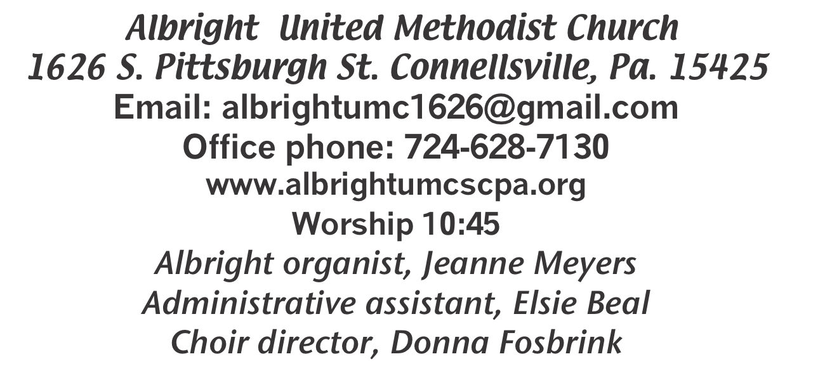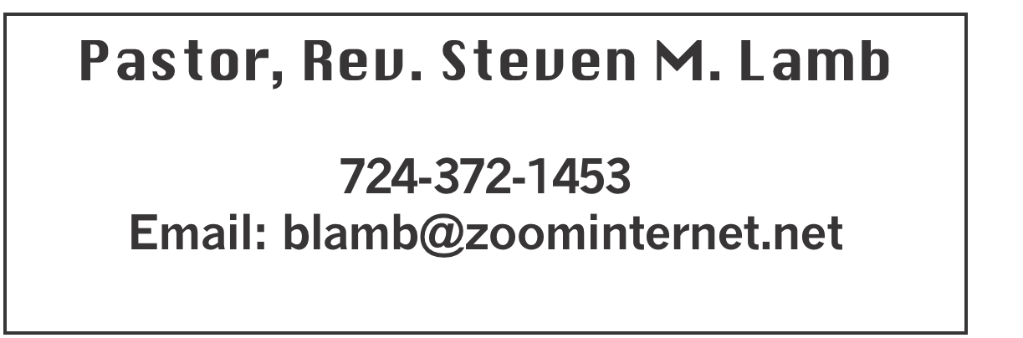

**\*\*\*\*\*\*\*\*\*\*\*\*\*\*\*\*\*\*\*\*\*\*\*\*\*\*\*\*\*\*\*\*\*\*\*\*\*\*\*\*\*\*\*\*\*\*\*\*\*\*\*\*\*\***

**August 25, 2024 Liturgist, Linda Burnworth 10:45a.m.**

**\*\*\*\*\*\*\*\*\*\*\*\*\*\*\*\*\*\*\*\*\*\*\*\*\*\*\*\*\*\*\*\*\*\*\*\*\*\*\*\*\*\*\*\*\*\*\*\*\*\*\*\*\*\*\*\***

**WELCOME AND ANNOUNCEMENTS**

**PRELUDE “The Windows of Heaven are Open” Unknown**

**BRI NGING FORTH THE LIGHT**

**\*OPENING HYMN “Tell Me the Stories of Jesus” 277**

**\*CALL TO WORSHIP**

**L: Calling all the children of the living God: the gospel is**

**good news for every age and every stage.**

P: Let us worship together, the young and the old.

**L: The good news is proclaimed in God’s words, and**

**also with crayons, silly songs, snacks and rest time.**

P: Let us worship together, every generation as a family of

faith.

**L: We may still feel uncertain, seeing so many faces**

**again, but we come together seeking God’s peace in**

**this beautiful community.**

***All: Let us worship together, united in Christ.***

**\*OPENING PRAYER**

**God, we give thanks that you have revealed yourself in the words of Scripture, read and proclaimed among us. We are grateful that you also make yourself known in bread and the fruit of the vine. We thank you for all the people who support and challenge us to be better disciples. Our greatest joy is to experience your presence and to respond to you, and we do this humbly today. Amen.**

**\*GLORIA PATRI 70**

**EPISTLE READING Ephesians 6:10-20**

**The word of God for the people of God. Thanks be to God.**

BLESSING OF BACKPACKS

**CHILDREN’S MOMENT & Coin Offering**

**PASSING THE PEACE**

**OFFERING**

**OFFERTORY Shelley Mattis & Donna Fosbrink**

**\*DOXOLOGY**

**\*OFFERTORY PRAYER**

**PRAYERS OFFERED IN PRAISE AND PETITION**

**PRAYER HYMN “Blest Be the Tie that Binds” 557**

**PASTORAL PRAYER**

**SILENT MEDITATION**

**THE LORD’S PRAYER**

**SPECIAL MUSIC Shelley & Donna**

**GOSPEL READING John 6:56-69**

**The word of God for the people of God. Thanks be to God.**

***Thy Word is a lamp unto my feet and a light unto my path***

**MESSAGE “Words of Eternal Life”**

**\*CLOSING HYMN “Wonderful Words of Life” 600**

**\*BENEDICTION**

**\*POSTLUDE**

**\*\*\*\*\*\*\*\*\*\*\*\*\*\*\*\*\*\*\*\*\*\*\*\*\*\*\*\*\*\*\*\*\*\*\*\*\*\*\*\*\*\*\*\*\*\*\*\*\***

WELCOME

***The psalmist prayed: “Restore us, O Lord God Almighty; make your face shine upon us, that we may be saved” (Psalm 80:19). May all who have come to worship find restoration, inner peace and spiritual strength. Welcome one and all!!***

**PRAYER CONCERNS THIS WEEK**

**Don Heckathorne Ray Knopsnider Thomas Leeder Paul & Myra Holden Baby Thompson Becky Irwin James & Deanna Sherbondy Trey Corvin Paula Snyder Susie Mongell Keith Morris Loretta Capo Allen Mellinger Kilee Robinson Chadd Tressler**

**Mary Swope Rich Marto Jeffrey Sarnelli Emma Jobbs Paul Martin**

**Margaret Shultz Donna Fosbrink Madelyn Johnson Larry Murray Jack Burke**

**Pat Tinkey Bobby Kozel Rev. Rob Kifer Kenny Urbach Salem Skukar**

**Shannon Mack Bradley Sharp Randy Jacobs Carol Daniels Denny Dunn**

**Kayla Hann Toni Jones Will Johnson Tina Hiltabidel Zack Martin**

**Scott Wagner Fred Grote Emryn Swaney Judy Strickler Donna Mills**

**Paula Shaffer Patty Lint Gary Bungard Taran Miller John Lypson**

**Karen Halfhill Shannon Halfhill Justin Keath Luke & Kara Cawood George Mariotti**

**Eddie John Buddy Richter Lee Mimless** Pastor Steve & Bev  **Rev. Ross Pryor Bishop Cynthia Moore-Koikoi**

Homebound persons: **Edna Baker, Polly Basinger, Evelyn Curry, Sherrill Goodwin, Chuck Hall, Charlotte Holt, Dolly King, Jimmy Lynn, Shirley Mathias, Stephanie**

**Mattis, Mariloyd McClintock, Ed Miller, Judy Morris, Dorene Provance, Ozella Roy**

Unspoken Requests All Military All churches

Government leaders Those with cancer

Those battling addiction Those on Hospice

Praise for answered prayers Homeless people

Families of those who take their own life

**THIS WEEK AT ALBRIGHT**

**TUESDAY: Blue Plate Special lunch 11-1**

**SUNDAY: Special music - Dave & Shelley Mattis**

OFFICE HOURS**: Tuesday, Wednesday, Thursday 10:00-3:00**

CO-OPERATIVE PARISH

**Will meet Tuesday, August 27 at 6:30 at Albright.**

**NOTE OF THANKS*: I would like to express my thanksgiving to the volunteers who made the “Onboarding Session” for the Connellsville District Superintendent a successful gathering of ministers and church leaders in our district. The accommodations were wonderful and the food (as always) was excellent. I am so proud of Albright church and its people. Thank you all. Pastor Steve***

DONATIONS FOR BENCHES

***We are asking for donations to help purchase benches for the gazebo. Cost is $265. Chairs are $160 each. We have samples in the gazebo. Any size donation will be***

***appreciated. Please use envelopes on the board in the back of sanctuary.***

BLUE PLATE SPECIAL

**Tues., Aug.27 at 11:00-1:00. Light lunch includes dessert & beverage. Free with donations accepted.**

OUTDOOR WORSHIP & PICNIC

**Sept. 8 at 10:45 will be our outdoor worship by Gazebo. It will be followed by a covered dish picnic in the pavilion. Bring a lawn chair for your comfort & a covered dish to share.**

SEPTEMBER CALENDAR

Sat., Sept. 7 @ 11:00 - Saturday Morning Special

Sun., Sept. 8 @ 10:45 - Outdoor worship service near the

Gazebo; followed by a covered dish picnic in the

pavilion. Bring a lawn chair for comfort.

Tues., Sept. 10 @ 7:00 - United Women in Faith mtg

Wed., Sept. 11 @ 6:30 - Weekly Bible study begins

Thurs., Sept. 12 @ 7:00 - Choir practices begin

Fri., Sept 13 & Sat., Sept 14 @ 10-1 Sub sale

Sat., Sept. 14 @ 10:00 - Basket class

Tues., Sept. 17 @ 7:00 - Church council meeting

Wed., Sept. 18 - Oct/Nov newsletter news deadline

Thurs., Sept. 19 @ 4-6 - Otterbein Pasta meal

Tues., Sept. 24 @ 11-1 - Blue plate special luncheon

Sun., Sept. 29 @ 10:45 Anniversary Sunday followed

by a potluck covered dish lunch

OUR STEWARDSHIP - August 18

**Weekly need for budget ........................................... $ 2,214.00**

**Sunday offering ............................................................... $ 1,527.00**

**Includes Coin offering $82.00**

**Sunday morning worship attendance ..................................... 58**

General Fund balance as of Aug. 1...... Minus - $20,264.71

Monthly need is $10, 506.38

JUNE (5 Sundays) income for the month was $9,624.65

JULY income for the month was $ 8,079.07

WE NEED YOUR HELP & SUPPORT!

**GREETING YOU TODAY: Larry & Lori Geisler**

**September 1: Dave & Shelley Mattis**

**LITURGIST: September 1: Jessica Bortz**

**September 8: Scott Murray**

**ACOLYTES TODAY: Andrew Lynn & Beau Wagner**

**September 1: Thelma Swope & Estella Gallagher**

**JUNIOR CHURCH TODAY: Katrina Bair & a volunteer**

**September 1: Kathy Hixson & Linda Burnworth**

**USHERS: Jeremy Gray, Scott Murray, Ed Jacobs, & Larry Bloom**

**Sept. 1:Jackie Bartholomai, Sherry Grote, Jeremy Gray & Ed Jacobs**

**COUNTERS: August: Jackie Bartholomai & Sally Fosbrink**

**September: Jay Whipkey & Karen Stimmell**

**SPECIAL MUSIC: September 1: Shelley & Davdd Mattis**

**September 8: Pastor Steve (outdoor service)**

SATURDAY MORNING SPECIAL

**This ministry for persons with special needs will gather Saturday, September 7 at 11:00. They will have grilled cheese & tomato soup.**

**UWF DAY APART AT JUMONVILLE**

Thursday, September 5. Registration 9:00; Program 9:30. Speaker: Trooper Blaine Henderson. Communion: Rev. Ross Prior, our new district Superintendent. Music: Bert Sesler. Soup & salad lunch $16; Brown bag $3. Need paid reservations by Aug. 22. We will be remembering Marilyn Banks & Jean Rahl at this event for the district.

**WEEKLY BIBLE STUDY**

**Will begin Wed., Sept. 11 at 6:30. Everyone is welcome.**