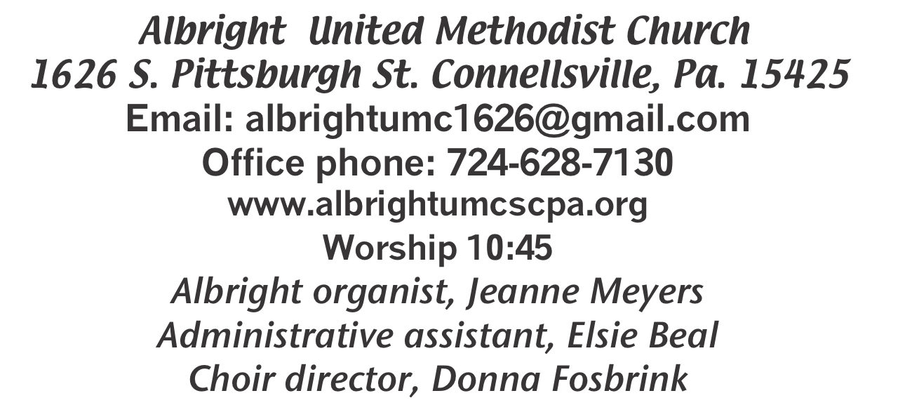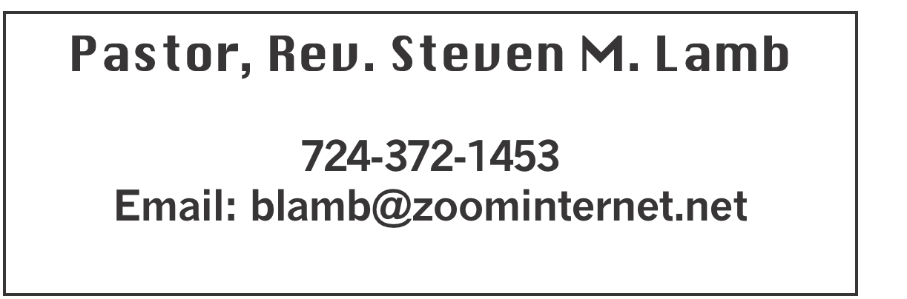

**\*\*\*\*\*\*\*\*\*\*\*\*\*\*\*\*\*\*\*\*\*\*\*\*\*\*\*\*\*\*\*\*\*\*\*\*\*\*\*\*\*\*\*\*\*\*\*\*\*\*\*\*\*\***

**June 9, 2024 Liturgist, Sherry Grote 10:45a.m.**

**\*\*\*\*\*\*\*\*\*\*\*\*\*\*\*\*\*\*\*\*\*\*\*\*\*\*\*\*\*\*\*\*\*\*\*\*\*\*\*\*\*\*\*\*\*\*\*\*\*\*\*\*\*\*\*\*\***

**WELCOME AND ANNOUNCEMENTS**

**PRELUDE “I Found the Answer” Lang**

**BRINGING FORTH THE LIGHT**

**\*OPENING HYMN “Great is Thy Faithfulness” 140**

**\*CALL TO WORSHIP**

**L: Jesus did not come to establish denominations.**

P: He came to bring salvation to all who call upon his holy name**.**

**L: Let us cast aside all that which is petty and irrelevant.**

P: Let us put away childish things which only serve to bring division and duress.

**L: The Lord calls us as one. God sees us as one.**

***All: We are the “church” together!***

**\*OPENING PRAYER**

**Unite us, Lord, in spite of our differences. Help us to run the race, encouraging each other regardless of stance, ever mindful of each person’s special place in the kingdom. You so delight in differences. Why is it so hard for us to see each person’s face as a reflection of your glory freely bestowed upon all your sons and daughters? May we be reminded that you, O Lord, are no respecter of persons. Amen**

**\*GLORIA PATRI 70**

**OLD TESTAMENT READING Psalm 130:1-8**

**The word of God for the people of God. Thanks be to God**

**CHILDREN’S MOMENT & Coin offering**

**\*PASSING THE PEACE**

**PRAYER REQUESTS**

**(give prayer cards to acolytes)**

**OFFERING**

**OFFEERTORY “No One Ever Cared for me Like Jesus” Weigle**

**\*DOXOLOGY**

**\*OFFERTORY PRAYER**

**PRAYERS OFFERED IN PRAISE AND PETITION**

**PRAYER HYMN “I Surrender All” 354**

**PASTORAL PRAYER**

**SILENT MEDITATION**

**THE LORD’S PRAYER**

**SPECIAL MUSIC Pastor Steve**

**GOSPEL READING Mark 3:20-35**

**The word of God for the people of God. Thanks be to God.**

***Thy Word is a lamp unto my feet and a light unto my path***

**MESSAGE “Build The Bridge and Get Over It”**

**\*CLOSING HYMN “Freely, Freely” 389**

**\*BENEDICTION**

**\*POSTLUDE**

**\*\*\*\*\*\*\*\*\*\*\*\*\*\*\*\*\*\*\*\*\*\*\*\*\*\*\*\*\*\*\*\*\*\*\*\*\*\*\*\*\*\*\*\*\*\*\*\*\***

WELCOME

***We are glad to have each worshiper among us today and***

***encourage all to worship with us on a regular basis. Thank you for your presence.***

**PRAYER CONCERNS THIS WEEK**

**Sandy Reich Don Heckathorne Betty Kooser Ray Knopsnider Thomas Leeder**

**Paul & Myra Holden Baby Thompson Bill Harden James & Deanna Sherbondy Amy Zavara**

**Trey Corvin Becky Irwin Paula Snyder Susie Mongell Keith Morris Loretta Capo Maggie Grimm Allen Mellinger Kilee Robinson Kathy Anthony Brennan Sechrist Gretchen Mundorff Barb & Buzz Stuart Ryker Klingensmith Mary Swope**

**Chadd Tressler Rich Marto Jeffrey Sarnelli Emma Jobbs Ron Lynch**

**Wyatt Corvin Paul Martin Margaret Shultz Lou Delossio Toni Hiltabidel**

**Stephen Mattis Donna Fosbrink Linda Burnworth Bill Bryner Madelyn Johnson Emogene Vinoski Sherrill Goodwin Donna Fosbrink Allen Thomas Larry Murray**

**P.J. & Jackie Holden & unborn baby Annie Vernino Joyce Shaffer Jack Burke**

**Rick Tressler Pat Tinkey** Pastor Steve & Bev  **Rev. Ross Pryor Rev. Bob & Amy Zilhaver Bishop Cynthia Moore-Koikoi**

Homebound persons: **Polly Basinger, Charlotte Holt, Dolly King, Shirley Mathias, Mariloyd McClintock, Edna Baker, Jimmy Lynn, Ozella Roy, Evelyn Curry, Judy Morris, Chuck Watson, Ed Miller, Dorene Provance, Jean Rahl, Sherrill Goodwin, Chuck Hall, Stephanie Mattis**

Unspoken Requests All Military All churches

Government leaders Those with cancer

Those battling addiction Praise for answered prayers

Families of those who take their own life

If you want a name on prayer list, please use the prayer cards in the pew - give to acolytes.

**THIS WEEK AT ALBRIGHT**

**TODAY: Covered dish picnic after church**

**TUESDAY: Connellsville West Cooperative mtg. 6:30**

**Charge Conference 7:30**

**THURSDAY: Children church meeting 6:00**

**SUNDAY: Special music: Mattis family & women of church**

OFFICE HOURS**: Tuesday, Wednesday, Thursday 10:00-3:00**

FATHER’S DAY PICNIC

**TODAY after church is a covered dish to honor ALL men of the church. Bring a dish to share and join us.**

CARNATIONS FOR FATHER’S DAY

**Red or white carnations for father’s day. $2.50 each.** ORDERS DUE TODAY.

CONNELLSVILLE WEST COOPERATIVE

**Representatives will meet 6:30 Tuesday, June 11.**

**Charge Conference meeting 7:30. At Albright.**

CHILDREN CHURCH

We will have a meeting Thursday, June 13 at 6:00 to discuss guidelines for Children’s church. We need all leaders to be present.

**BUS TRIP TO LANCASTER**

**Thursday, June 20 we will go to see Daniel at Lancaster. Leave at 6:30 a.m. and return at about 10:00 p.m.**

CRAFT, VENDOR SHOW

**Saturday, July 13 @ 9a.m. to 4p.m. (One day only) with food trucks on sight. Cost is $25 first table $15 thereafter. Outside space $20 for 1; $10 thereafter. Bring your own tables & tents for outside. We have application forms available to return with your fee (nonrefundable). Please return by June 10. Any questions call 724-628-6772 or 724-372-1456.**

**ALTAR FLOWERS**

**If you are putting flowers on the altar, please call the office by Tuesday morning (or sooner) and let us know.**

OUR STEWARDSHIP - June 2

**Weekly need for budget ........................................... $ 2,214.00**

**Sunday offering ............................................................... $ 1,973.00**

**(Includes coin offering $106.00)**

**Sunday morning worship attendance .............................. 76**

**GREETING YOU TODAY: Myra Holden**

**June 16: Eve Shupe**

**LITURGISTS: June 16: Eve Shupe**

**June 23: Bonnie Bloom**

**ACOLYTES TODAY: Thelma Swope & Emmaleigh Kalemba**

**June 16: Kayton & Keelan Callahan**

**CHILDREN CHURCH TODAY: Kelli Armstrong & Nancy Mimless**

**June 16: Bonnie & Larry Bloom**

**USHERS: Larry Bloom, Scott Murray, Sally Fosbrink, Michelle Reich**

**June 16: Jay & Judy Whipkey, Linda Burnworth, Pinky Smiley**

**COUNTERS: June: Ed Jacobs & Nancy Mimless**

**July: Karen Marko & Linda Burnworth**

**SPECIAL MUSIC: 16: Women sing for Father’s day; & Mattis family**

**June 23: Bonnie Bloom**

BASKET CLASS

**Elsie will have a basket class Saturday, July 20 at 10:00. $20 for class ($15 goes to the church). Let Elsie know if you or anyone you know plan to attend.**

STREAKFREE CLOTHS

We have the Streak Free cleaning cloths. They are $4 each. See Elsie or stop by the office to get them.

**FATHER’S DAY CARNATIONS**

**Father’s day is June 16. We are offering carnations for you to purchase in Loving Memory or Loving Honor of someone special to you. All will be to the GLORY OF GOD. They are available in red or white and cost $2.50 each.**

**Please use the order form below to place your paid order before June 9.**

**Fill out the form below and put it with your money in an envelope and give to Elsie or put in offering plate.**

**We need paid orders in to the office by JUNE 9**

**NO ORDERS ACCEPTED AFTER THAT DATE**

**-----------------------------------------------------------------------------**

**Father’s Day Carnation Order - $2.50 each**

**ORDER BY JUNE 9**

**______ White _______ Red**

**(How many) (How many)**

**IN LOVING MEMORY OF IN LOVING HONOR OF**

**(Please circle one)**

**___________________________________________________**

**___________________________________________________**

**Given by: __________________________________________**

**___________________________________________________**

**Amount enclosed $______________**