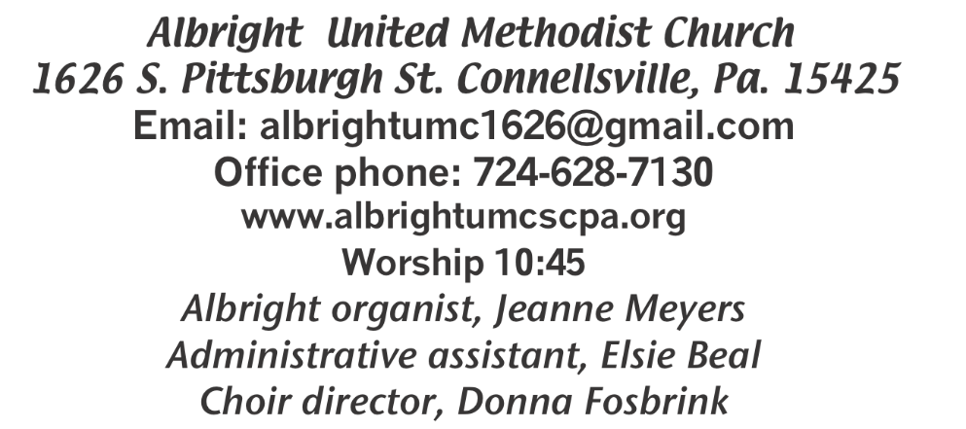



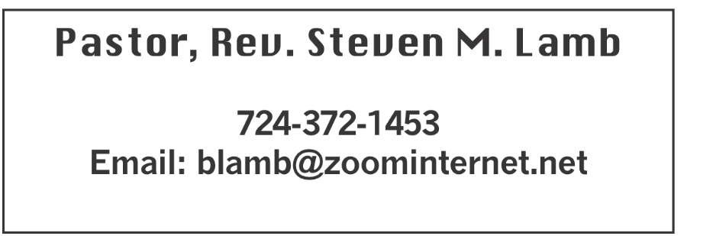

**\*\*\*\*\*\*\*\*\*\*\*\*\*\*\*\*\*\*\*\*\*\*\*\*\*\*\*\*\*\*\*\*\*\*\*\*\*\*\*\*\*\*\*\*\*\*\*\*\*\*\*\*\*\***

**June 30, 2024 Liturgist, Karen Stimmell 10:45a.m.**

**Independence Day Sunday**

**\*\*\*\*\*\*\*\*\*\*\*\*\*\*\*\*\*\*\*\*\*\*\*\*\*\*\*\*\*\*\*\*\*\*\*\*\*\*\*\*\*\*\*\*\*\*\*\*\*\*\*\*\*\*\***

**WELCOME AND ANNOUNCEMENTS**

**PRELUDE “Statue of Liberty” Enloe**

**BRINGING FORTH THE LIGHT**

**\*OPENING HYMN “Leaning on the Everlasting Arms” 133**

**\*CALL TO WORSHIP**

**One: God, you seek us out:**

***All: In the dead of night***

**One: And on this bright morning;**

***All: In the depths of despair***

**One: And in the valleys of worry.**

***All: Holy One, you shake us from complacency,***

**One: Wrestling fear from our souls**

***All: And caution from our plans.***

**One: Loving God, you draw near,**

***All: As close as our breathing,***

**One: As present as the beat of our hearts.**

***All: Loving God, you jealously desire our attention,***

**One: Rejoice at our singing,**

***All: And welcome our worship***

**\*OPENING PRAYER**

**O God, your graciousness is found in a cool breeze on a warm night; your compassion is seen in the embrace given to a person suffering illness; your joy is noticed in children jumping rope and in the elderly couple holding hands; your peace is felt when we know that we are being lifted up in prayer. You are the song in every singer’s heart; you are the touch in every lover’s embrace; you are the spark in every creative moment. Our hearts long to praise you, and we hope our lives please you. On this day, kindle a memory of joy, light a candle of hope, heal a broken relationship, grant a forgiveness that is deeper than “I’m sorry.” In Jesus’ name. Amen.**

**\*GLORIA PATRI 70**

**OLD TESTAMENT READING Job 1:1-22**

**The word of God for the people of God. Thanks be to God**

**CHILDREN’S MOMENT & Coin Offering**

**PASSING THE PEACE**

**OFFERING**

**OFFERTORY “The Lighthuse” Lori Geisler**

**\*DOXOLOGY**

**\*OFFERTORY PRAYER**

**PRAYERS OFFERED IN PRAISE AND PETITION**

**PRAYER HYMN “It Is Well with My Soul” 377**

**PASTORAL PRAYER**

**SILENT MEDITATION**

**THE LORD’S PRAYER**

**SPECIAL MUSIC “Fragile Heart” Lori Geisler**

**EPISTLE READING Ephesians 6:16**

**The word of God for the people of God. Thanks be to God.**

***Thy Word is a lamp unto my feet and a light unto my path***

**MESSAGE “Choosing Faith”**

**\*CLOSING HYMN “Here I Am, Lord” 593**

**\*BENEDICTION**

**\*POSTLUDE**

**\*\*\*\*\*\*\*\*\*\*\*\*\*\*\*\*\*\*\*\*\*\*\*\*\*\*\*\*\*\*\*\*\*\*\*\*\*\*\*\*\*\*\*\*\*\*\*\*\*\*\***

WELCOME

***This is Independence Sunday. With great gratitude for freedom of worship, let us thank God for our nation. Let us also greet one another with loving kindness as we praise God. Welcome to all.***

**PRAYER CONCERNS THIS WEEK**

**Don Heckathorne Ray Knopsnider Thomas Leeder Paul & Myra Holden Baby Thompson Bill Harden James & Deanna Sherbondy Amy Zavara Trey Corvin Becky Irwin**

**Paula Snyder Susie Mongell Keith Morris Loretta Capo Maggie Grimm Allen Mellinger Kilee Robinson Kathy Anthony Brennan Sechrist Gretchen Mundorff Barb & Buzz Stuart Ryker Klingensmith Mary Swope Chadd Tressler Rich Marto**

**Jeffrey Sarnelli Emma Jobbs Paul Martin Margaret Shultz Toni Hiltabidel Donna Fosbrink Linda Burnworth Bill Bryner Madelyn Johnson Emogene Vinoski Allen Thomas Larry Murray Jack Burke Pat Tinkey**

**P.J. & Jackie Holden & unborn baby Bobby Kozel Carol Daniels John Kuzyck**

**Rev. Rob Kifer Kenny Urbach Traveling mercies for Richard & Erica Burnworth**

**Young family in car accident; mom in bad shape, 6 yr old killed, 2 other kids hurt Chuck Watson**

Pastor Steve & Bev  **Rev. Ross Pryor Bishop Cynthia Moore-Koikoi**

Homebound persons: **Polly Basinger, Charlotte Holt, Dolly King, Shirley Mathias, Mariloyd McClintock, Edna Baker, Jimmy Lynn, Ozella Roy, Evelyn Curry, Judy Morris, Chuck Watson, Ed Miller, Dorene Provance, Jean Rahl, Sherrill Goodwin, Chuck Hall, Stephanie Mattis**

Unspoken Requests All Military All churches

Government leaders Those with cancer

Those battling addiction Those on Hospice

Praise for answered prayers

Families of those who take their own life

IF YOU WANT A NAME ON PRAYER LIST, PLEASE USE THE PRAYER CARDS IN THE PEW - give to Acolytes.

**THIS WEEK AT ALBRIGHT**

**TODAY: Potluck covered dish after church**

**TUESDAY: Event planning meeting 6:00**

**SUNDAY: Special music - Ray Knopsnider**

OFFICE HOURS**: Tuesday, Wednesday, Thursday 10- 3**

OUR STEWARDSHIP - June 23

**Weekly need for budget ........................................... $ 2,214.00**

**Sunday offering ............................................................... $ 1,883.00**

**Sunday morning worship attendance .............................. 61**

**GREETING YOU TODAY: Sandy Russell**

**July 7: Davd & Shelley Mattis**

**LITURGISTS: July 7: Donna Fosbrink**

**July 14: Bev Lamb**

**ACOLYTES TODAY: Aubree & Kadey Shaffer**

**July 7: Piper Marko & Jameson Tony**

**JUNIOR CHURCH TODAY: Bonnie & Larry Bloom**

**July 7: Kathy Hixson & Linda Burnworth**

**USHERS: Volunteers**

**July 7:Jackie Bartholomai, Jeremy Gray, Sherry Grote, Ed Jacobs**

**COUNTERS: June: Ed Jacobs & Nancy Mimless**

**July: Karen Marko & Linda Burnworth**

**SPECIAL MUSIC: July 7: Ray Knopsnider**

**July 14: Jeanne Meyers & Sharon Grimm**

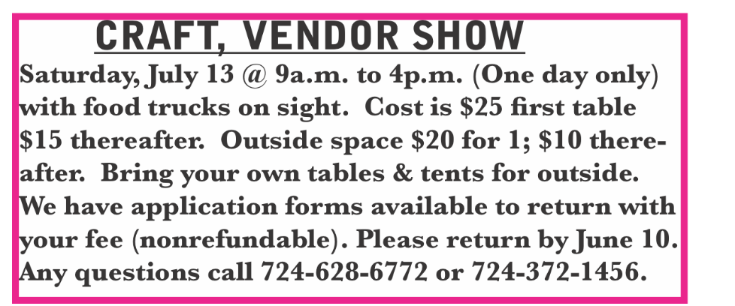

**STREAKFREE CLOTHS**

We have the Streak Free cleaning cloths. They are $4 each. See Elsie or stop by the office to get them.

FIFTH SUNDAY POTLUCK

TODAY after church we will have a potluck lunch. Stay and join the fellowship following the morning worship.

**PLANNING MEETING**

**An event planning meeting will be held Tuesday, July 2 at 6:00**

SUB SALE

***Friday, July 19 & Saturday, July 20 beginning at 10:00. 12” sub $10. Condiments all packaged separately for quality & freshness. Please use order forms to get your order in early.***

BASKET CLASS

**Elsie will have a basket class Saturday, July 20 at 10:00. $20 for the class. Let Elsie know if you or anyone you know plan to attend.**

DONATIONS FOR BENCHES

**We are asking for donations to help purchase benches for the gazebo. We have a sample in the downstairs hallway for you to see. Any size donation will be appreciated. Please use envelopes on the board in the back of sanctuary.**

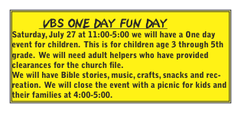

JUNIOR CHURCH GUIDELINES & RULES

**This is for persons age 3 through 5th grade. It is a form of worship geared to younger people. This is to prepare them for confirmation when they are old enough to join the church.**

**Junior church is for worship instruction.**

**Babies and younger children are always welcome in our**

**worship services. If they need extra care, there is a nursery room provided downstairs for adult guardians who need to take them there. Due to laws of our state, teens cannot be responsible for young children.**

**Anyone sixth grade and older will be required to stay upstairs during the worship service.**

**We have responsible leaders who work in pairs each week. There will be a format to follow each week.**

**Begin with prayer**

**Bible Lesson**

**Song (s)**

**Craft**

**Snacks**

**Children are expected to stay in their seats and be respectful to the leaders. If a child is having an off day, they will be taken back upstairs to the parents.**

**They are to remain in the Junior Church room the entire time they are there. They are to raise their hands if they have questions.**

**They will be learning Lord’s Prayer, Doxology, Books of the Bible, Disciples, Stories of God’s chosen people of the Bible.**

**Thank you very much to those who have been willing to help with our children.**

CRAFT & VENDOR SHOW

**Saturday, July 13**

**9:00 - 4:00**

Albright U.M. Church

South Connellsville

Variety of homemade items and several vendors

Kitchen open: Sandwiches for sale

Food Trucks on Site

**SUB SALE**

**Seller _______________________________ 12” Subs $10.00**

**Day Name Phone # How many Total Due Paid**

**1. ______________________________________________________________**

**2._______________________________________________________________**

**3._______________________________________________________________**

**4._______________________________________________________________**

**5._______________________________________________________________**

**6._______________________________________________________________**

**7._______________________________________________________________**

**8._______________________________________________________________**

**9._______________________________________________________________**

**10.______________________________________________________________**

**11.______________________________________________________________**

**12.______________________________________________________________**

**Orders due by July 14. May be picked up Friday, July 19 & Saturday, July 20 @ 10-1 or until sold out at Albright UM Church.**

