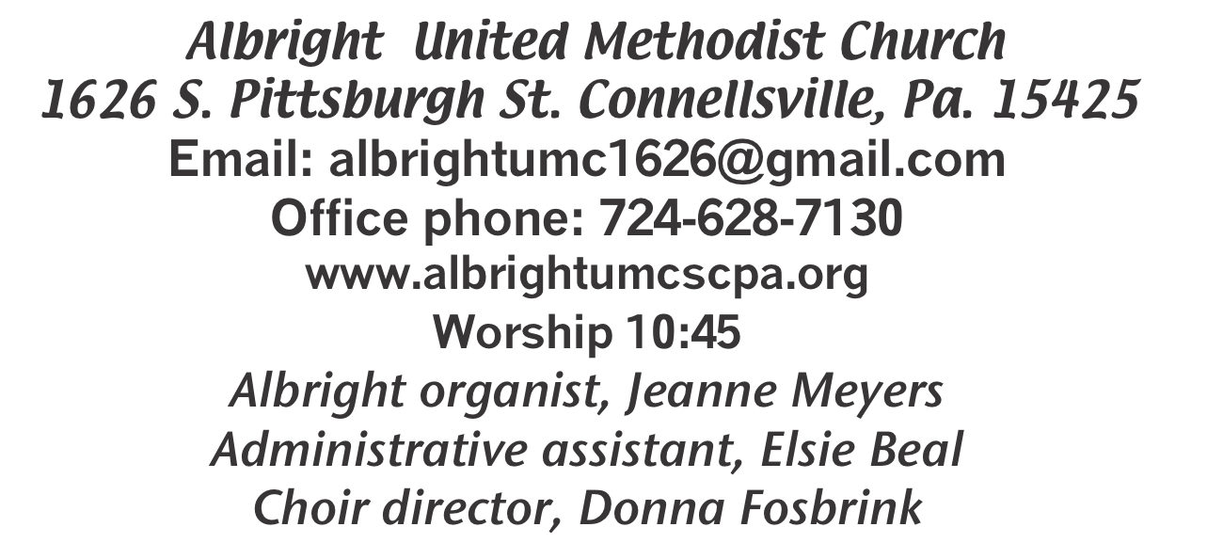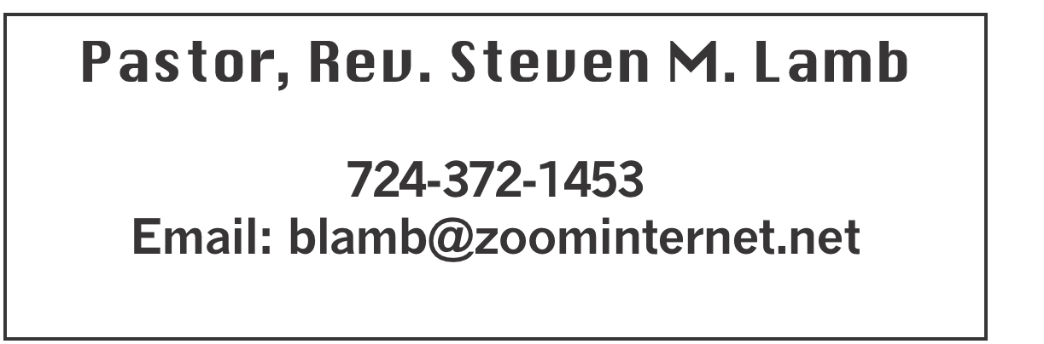

**\*\*\*\*\*\*\*\*\*\*\*\*\*\*\*\*\*\*\*\*\*\*\*\*\*\*\*\*\*\*\*\*\*\*\*\*\*\*\*\*\*\*\*\*\*\*\*\*\*\*\*\*\*\***

**June 23, 2024 Liturgist, Bonnie Bloom 10:45a.m**

**\*\*\*\*\*\*\*\*\*\*\*\*\*\*\*\*\*\*\*\*\*\*\*\*\*\*\*\*\*\*\*\*\*\*\*\*\*\*\*\*\*\*\*\*\*\*\*\*\*\*\*\*\*\*\*\***

**WELCOME AND ANNOUNCEMENTS**

**PRELUDE “Bring Them In” Ogden**

**BRINGING FORTH THE LIGHT**

**\*OPENING HYMN “Wonderful Words of Life” 600**

**\*CALL TO WORSHIP: An Affirmation of Faith**

**L: In a time before all knowing, God is, and God’s breath fills**

**the emptiness, creating: a universe, a world, an ecology, a**

**biology and us, humankind. All humankind, no exceptions,**

**no imperfections; and all of us beloved just as we are.**

P: In a time before all knowing, Christ Jesus watches the

creating, and steps out into creation: becoming, living, dying

and rising, all for us. All humankind, no exceptions, no

reservations; all of us just as we are, God’s beloved.

***All: In a time before all knowing, the Spirit is, and moves***

***through every part of creation: consoling, interceding,***

***leading and refreshing all the world, including us. All***

***humankind, no exceptions, no differentiations; all of us***

***just as we are, God’s beloved.***

**\*OPENING PRAYER**

**Holy Spirit, move in us today. Set our mind on things above, not on earthly things. Remove our pride, and clear our distracted minds so that all we hear is your truth. Allow the Scriptures to be life-changing and to renew our desire for you. Help us to understand clearly the message of your Word. We want to know you more. Thank you for the message we will hear today. Amen.**

**\*GLORIA PATRI 70**

**EPISTLE READING 2 Corinthians 6:1-13**

**The word of God for the people of God. Thanks be to God.**

**CHILDREN’S MOMENT & Coin Offering**

**PASSING THE PEACE**

**OFFERING**

**OFFERTORY SPECIAL MUSIC by Bonnie Bloom**

**\*DOXOLOGY**

**\*OFFERTORY PRAYER**

**PRAYERS OFFERED IN PRAISE AND PETITION**

**PRAYER HYMN “Jesus Is All the World to Me” 469**

**PASTORAL PRAYER**

**SILENT MEDITATION**

**THE LORD’S PRAYER**

**SPECIAL MUSIC Bonnie Bloom**

**GOSPEL READING Mark 4:35-41**

**The word of God for the people of God. Thanks be to God.**

***Thy Word is a lamp unto my feet and a light unto my path***

**MESSAGE “Naming Your Storm”**

**\*CLOSING HYMN “Majesty Worship His Majesty” 176**

**\*BENEDICTION**

**\*POSTLUDE**

**\*\*\*\*\*\*\*\*\*\*\*\*\*\*\*\*\*\*\*\*\*\*\*\*\*\*\*\*\*\*\*\*\*\*\*\*\*\*\*\*\*\*\*\*\*\*\*\*\***

WELCOME

***We rejoice in having each of you here for worship. Your presence lifts our spirits. Remembering the love which God has for us, let us extend our hands in love and respect to one another.***

**PRAYER CONCERNS THIS WEEK**

**Don Heckathorne Ray Knopsnider Thomas Leeder Paul & Myra Holden Baby Thompson Bill Harden James & Deanna Sherbondy Amy Zavara Trey Corvin Becky Irwin**

**Paula Snyder Susie Mongell Keith Morris Loretta Capo Maggie Grimm Allen Mellinger Kilee Robinson Kathy Anthony Brennan Sechrist Gretchen Mundorff**

**Barb & Buzz Stuart Ryker Klingensmith Mary Swope Chadd Tressler Rich Marto**

**Jeffrey Sarnelli Emma Jobbs Paul Martin Margaret Shultz Toni Hiltabidel Donna Fosbrink Linda Burnworth Bill Bryner Madelyn Johnson Emogene Vinoski Allen Thomas Larry Murray Joyce Shaffer P.J. & Jackie Holden & unborn baby**

**Jack Burke Pat Tinkey Bobby Kozel Rob Kifer Kenny Urbach**

Pastor Steve & Bev  **Rev. Ross Pryor Rev. Bob & Amy Zilhaver Bishop Cynthia Moore-Koikoi**

Homebound persons: **Polly Basinger, Charlotte Holt, Dolly King, Shirley Mathias, Mariloyd McClintock, Edna Baker, Jimmy Lynn, Ozella Roy, Evelyn Curry, Judy Morris, Chuck Watson, Ed Miller, Dorene Provance, Jean Rahl, Sherrill Goodwin, Chuck Hall, Stephanie Mattis**

Unspoken Requests All Military All churches

Government leaders Those with cancer

Those battling addiction Praise for answered prayers

Families of those who take their own life

**THIS WEEK AT ALBRIGHT**

**TUESDAY: Blue Plate special 11:00-1:00**

**SUNDAY: Special music - Lori Geisler**

OFFICE HOURS**: Tuesday, Wednesday, Thursday 10:00-3:00**

**AUGUST/SEPTEMBER NEWSLETTER**

***News deadline is July 24. They will be out in pews on***

***July 28.***

BLUE PLATE SPECIAL

**Tuesday, June 25 at 11:00-1:00. Donations accepted, but not required. $5 for take outs.**

**FIFTH SUNDAY POTLUCK**

Sunday, June 30 after church we will have a potluck lunch. Bring a dish to share and join the fellowship following the morning worship.

**PLANNING MEETING**

**An event planning meeting will be held Tuesday, July 2 at 6:00**

CRAFT, VENDOR SHOW

**Saturday, July 13 @ 9a.m. to 4p.m. (One day only) with food trucks on sight. Cost is $25 first table $15 thereafter. Outside space $20 for 1; $10 thereafter. Bring your own tables & tents for outside. We have application forms available to return with your fee (nonrefundable). Please return by June 10. Any questions call 724-628-6772 or 724-372-1456.**

SUB SALE

***Friday, July 19 & Saturday, July 20 beginning at 10:00. 12” sub $10. Condiments all packaged separately for quality & freshness.***

BASKET CLASS

**Elsie will have a basket class Saturday, July 20 at 10:00. $20 for the class. Let Elsie know if you or anyone you know plan to attend.**

DONATIONS FOR BENCHES

**We are asking for donations to help purchase benches for the gazebo. We have a sample in the downstairs hallway for you to see. Any size donation will be appreciated. Please use envelopes on the board in the back of sanctuary.**

**ALTAR FLOWERS**

**If you are putting flowers on the altar, please call the office by Tuesday morning (or sooner) and let us know.**

OUR STEWARDSHIP - June 16

**Weekly need for budget ........................................... $ 2,214.00**

**Sunday offering ............................................................... $ 1,106.65**

**Sunday morning worship attendance .............................. 41**

**GREETING YOU TODAY: Larry & Lori Geisler**

**June 30: Sandy Russell**

**LITURGISTS: June 30: Karen Stimmell**

**July 7: Donna Fosbrink**

**ACOLYTES TODAY: Kamrie Kimmel & Olivia Lynn**

**June 30: Aubree & Kadey Shaffer**

**CHILDREN CHURCH TODAY:**

**June 30: Shelley Mattis & Mandy Lynn**

**USHERS: Jeremy Gray, Scott Murray, Ed Jacobs, Larry Bloom**

**June 30: Volunteers**

**COUNTERS: June: Ed Jacobs & Nancy Mimless**

**July: Karen Marko & Linda Burnworth**

**SPECIAL MUSIC: 30: Lori Geisler**

**July 7: Ray Knopsnider**

STREAKFREE CLOTHS

We have the Streak Free cleaning cloths. They are $4 each. See Elsie or stop by the office to get them.

