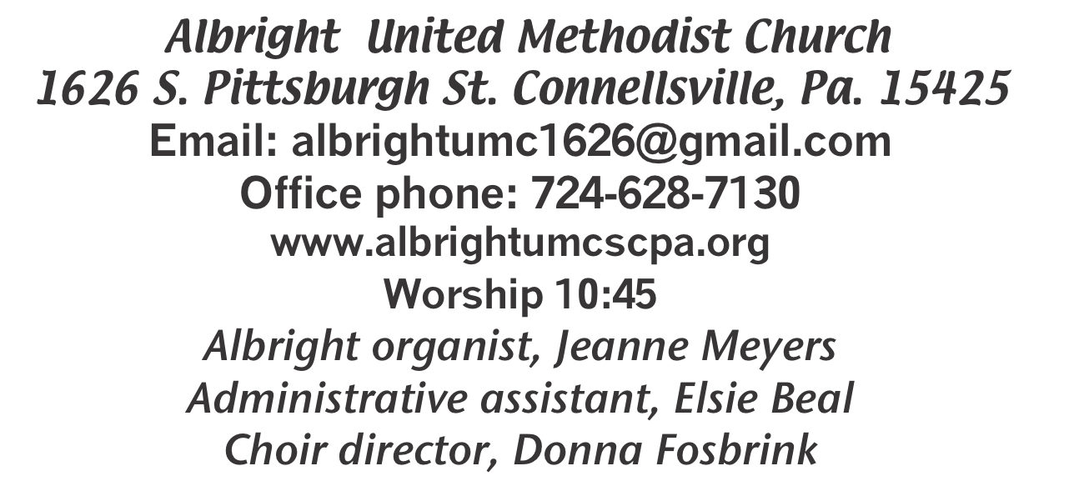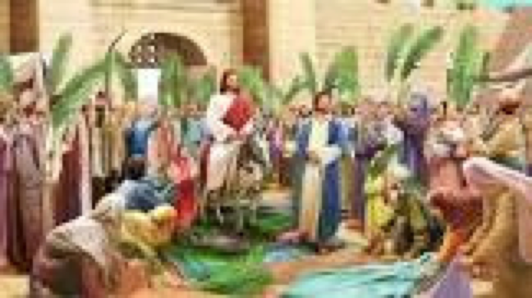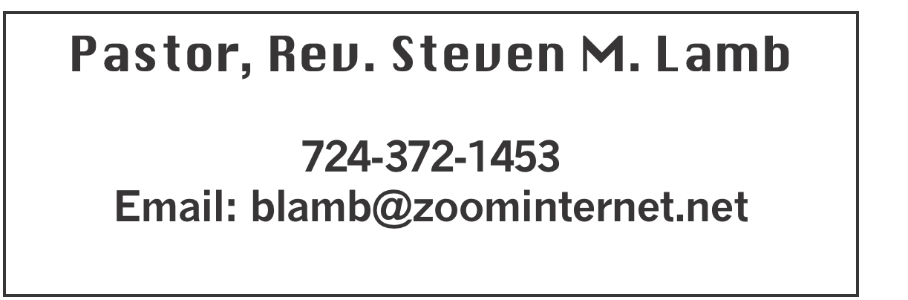

**\*\*\*\*\*\*\*\*\*\*\*\*\*\*\*\*\*\*\*\*\*\*\*\*\*\*\*\*\*\*\*\*\*\*\*\*\*\*\*\*\*\*\*\*\*\*\*\*\*\*\*\*\*\*\*\*\*\*\*\***

**March 24, 2024 Liturgist, Bev Lamb 10:45a.m**

**Palm Sunday**

**\*\*\*\*\*\*\*\*\*\*\*\*\*\*\*\*\*\*\*\*\*\*\*\*\*\*\*\*\*\*\*\*\*\*\*\*\*\*\*\*\*\*\*\*\*\*\*\*\*\*\*\*\*\*\***

**WELCOME AND ANNOUNCEMENTS**

**PRELUDE “Crown Him” Morris**

**BRINGING FORTH THE LIGHT**

**\*OPENING HYMN “Hosanna! Loud Hosanna” 278**

**\*CALL TO WORSHIP**

**L: “Go into the village ahead of you, and immediately as**

**you enter it you will find tied there a colt that has never**

**been ridden; untie it and bring it.**

P: If anyone says to you, ‘Why are you doing this?’ just say

this: ‘The Lord needs it.’”

**L: Your King comes to you righteous and victorious,**

P: Lowly and riding on a donkey, on a colt, the foal of a

donkey.

**L: Hosanna! Blessed is he who comes in the name of the**

**Lord!**

P: Blessed be the King who comes in the name of the

Lord!

**L: If we should be silent, the stones would cry out!**

P: No stone shall cry out for me!

***All: Hosanna! Praise be to the name of our Lord, Jesus the Christ! Hosanna to our King!***

**\*OPENING PRAYER**

**Almighty God, you sent your Son, our Savior Jesus Christ, to suffer death on the cross. Grant that we may share in obedience to your will and in the glorious victory of his resurrection; through Jesus Christ our Lord, who lives and reigns with you and the Holy Spirit, One God, now and ever. Amen**

**\*GLORIA PATRI 70**

**OLD TESTAMENT READING Psalm 118:1-2, 19-20**

**The word of God for the people of God. Thanks be to God.**

**CHILDREN’S MOMENT & Coin Offering**

**PASSING THE PEACE**

**PRAYER REQUESTS**

**(give prayer cards to acolytes)**

**OFFERING**

**OFFERTORY “Hosanna!” Weston**

**\*DOXOLOGY**

**\*OFFERTORY PRAYER**

**PRAYERS OFFERED IN PRAISE AND PETITION**

**PRAYER HYMN “All Glory, Laud and Honor” 280**

**PASTORAL PRAYER**

**SILENT MEDITATION**

**THE LORD’S PRAYER**

**ANTHEM “Why Does He Seem To be So Sad?”**

**GOSPEL READING John 12:12-16**

**The word of God for the people of God. Thanks be to God.**

***Thy Word is a lamp unto my feet and a light unto my path***

**MESSAGE “A King’s Ransom”**

**\*CLOSING HYMN “Lord of the Dance” 261**

**\*BENEDICTION**

**\*POSTLUDE**

**\*\*\*\*\*\*\*\*\*\*\*\*\*\*\*\*\*\*\*\*\*\*\*\*\*\*\*\*\*\*\*\*\*\*\*\*\*\*\*\*\*\*\*\*\*\*\*\*\***

WELCOME

***On this joyous Palm Sunday, we happily welcome each***

***worshiper. In our hearts let us all praise our Lord and King, Jesus the Christ.***

**PRAYER CONCERNS THIS WEEK**

**Tom McMurray Tina Hiltabidel Janice Bailey David & Tammy Leeder Misty Hiltabidel Sandy Reich Don Heckathorne Betty Kooser Chuck Watson Ray Knopsnider Thomas Leeder Paul & Myra Holden Parker Scary Baby Thompson Brian Foz**

**James & Deanna Sherbondy Bill Harden Amy Zavara Trey Corvin Becky Irwin**

**John Welsh Sara Gianotti Bill Bauer Bonnie Folly Paula Snyder Susie Mongell Keith Morris John Yost Pat McClelland Katy & Travis Terry Mattis Tilly Harvey Kara McMullen Loretta Capo Sheila Hart**

**Ralph Bliss Maggie Grimm Allen Mellinger Kelly Thompson Jeff Spiker**

**Beverly Sheppard Pat Tikey Kilee Robinson Judy McClain Kathy Anthony**

**Brennan Sechrist Bonnie Parker Barb & Buzz Stuart Jan & Brian Haviker Ryker Klingensmith Kay Jacobs Mary Swope Ray Vukson Pastor Steve & Bev**  **Rev. Bob & Amy Zilhaver Bishop Cynthia Moore-Koikoi**

Homebound persons: **Polly Basinger, Charlotte Holt, Dolly King, Sue Corvin, Shirley Mathias, Mariloyd McClintock, Edna Baker, Jimmy Lynn, Ozella Roy, Evelyn Curry, Judy Morris, Chuck Watson, Ed Miller, Dorene Provance, Jean Rahl, Sherrill Goodwin, Chuck Hall, Stephanie Mattis**

Unspoken Requests All Military All churches Government leaders Those with cancer

Those battling addiction Families of those who take their own life

If you want a name on prayer list, please use the prayer cards in the pew - give to acolytes.

**THIS WEEK AT ALBRIGHT**

**TODAY: Last Supper practice 2:00**

**TUESDAY: Blue Plate Special 11:00-1:00**

**WEDNESDAT: Last Supper dress rehearsal 6:00**

**THURSDAY: Maundy Thursday service 7:00 at Otterbein**

**FRIDAY: Good Friday service 7:30 at Albright**

**SUNDAY: Sunrise service 7:00 a.m. at Albright & breakfast**

**Regular worship 10:45**

**OFFICE HOURS: Tuesday, Wednesday, Thursday 10- 3**

***LAST SUPPER PRACTICE***

**Rehearsal for the Last Supper play will be Sunday, March 24th @2PM and Wednesday, March 27th @ 6PM for a full dress rehearsal.**

**The play will take place on Maundy Thursday, March 28th @ 7PM at Otterbein. A dinner of roast beef, parsley potatoes and green beans will be served prior to the play at 6PM**

SPPRC MEETING

**Albright March 26th 7PM. Those on this committee: Sandy Russell, Eve Shupe, Jeremy Gray, Vicky Adey, David Mattis, Bonnie Bloom, Rick Tressler.**

**YOUTH NEWS**

*Youth group (grade 3 through 12). They meet the 2nd & 4th Sunday mornings (April 14 & 28) at 1O:OO at the church.*

**EASTER CANDY Pick up orders anytime. See Bev to arrange pick up.**

BLUE PLATE SPECIAL

**Tuesday, March 26 at 11:00-1:00. Light lunch. Free with donations accepted. $5 for take out.**

UNITED WOMEN IN FAITH

**Will meet Tuesday, April 9 at 7:00. Hosting are Donna Fosbrink & Shelley Mattis. Devotions by Shelley. We are planning for the Mother/Daughter dinner on Monday, May 13 at 6:00. ALL WOMEN of the church are invited to join us for the meetings.**

NOTE OF THANKS

**Thank you to everyone who donated toward the cost of the Easter Dinner yesterday. Thanks to those who helped serve meals. As always, your help & support are greatly appreciated.**

**ALTAR FLOWERS**

**To the GLORY OF GOD and IN LOVING MEMORY of Evelyn Butela - given by daughter, Evelyn Curry & granddaughter, Vicky Adey.**

OUR STEWARDSHIP - March 17

**Weekly need for budget ........................................... $ 2,214.00**

**Sunday offering ............................................................... $ 2,231.65**

**(Includes coin offering $104)**

**Sunday morning worship attendance .............................. 70**

**GREETING YOU TODAY: Bill Harden or Jackie Bartholomai**

**March 31: Nancy Mimless & Ed Jacobs**

**LITURGISTS: March 31: Emma Karfelt**

**April 7: Karen Marko**

**ACOLYTES TODAY: Thelma Swope & Beau Wagner**

**March 31: Andrew Lynn & Emmaleigh Kalemba**

**CHILDREN’S CHURCH: NEED VOLUNTEERS**

**March 31: Shelley Mattis & Mandy Lynn**

**USHERS: Jeremy Gray, Fred Grote, Ed Jacobs, Larry Bloom**

**March 31: Karen ask for volunteers**

**COUNTERS: Linda Burnworth & Jackie Bartholomai**

**HOLY WEEK WORSHIP OPPORTUNITIES**

**Thursday, March 28: Maundy Thursday worship 7:00**

**at Otterbein. Re-enactment of the Last Supper.**

**Friday, March 29: Good Friday service 7:30 at Albright.**

**Sunday, March 31: Sunrise service 7:00 a.m. at Albright.**

**Light breakfast to follow the service.**

**Regular worship service 10:45.**

CRAFT, COLLECTABLES, VENDOR SHOW

**Saturday, July 13 9a.m. to 4p.m. (One day only) with food trucks on sight. Cost is $25 first table $15 thereafter. Outside space $20 for 1; $10 thereafter. Bring your own tables & tents for outside. We have application forms available to return with your fee (nonrefundable). Please return by June 10. Any questions call 724-628-6772 or 724-628-7130.**